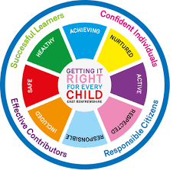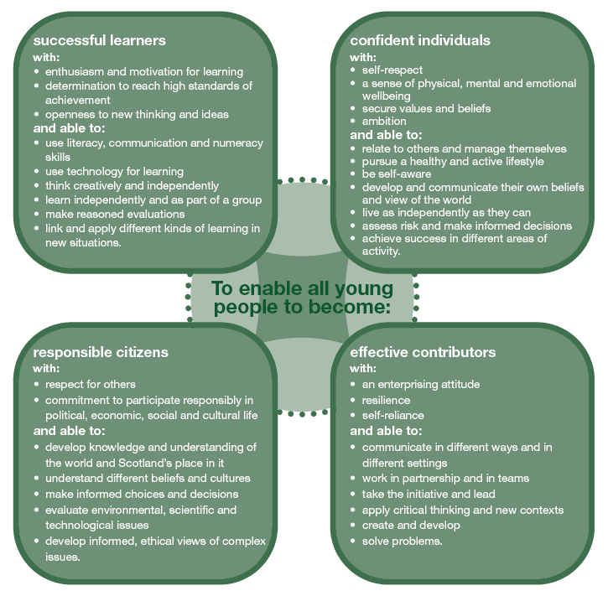

Health and Well-being Indicators

All children should be…

**The purpose of the curriculum…**

**The 4 Capacities…**

**Skene School Curriculum Rationale**

“Working together, learning together, to be the best we can be”

**Our 5 Values**

* **Being Safe**
* **Can Do Attitude/Growth Mindset**
* **Opportunities for All**
* **Partnership Working**
* **Respect for Everyone**

Teachers and pupils plan through **discrete learning,** c**ross-curricular learning** and **interdisciplinary learning.**

Health and Wellbeing

Expressive Arts

Science

RME

Literacy and English

Mathematics

Technologies

Social Studies

**The 8 Curricular Areas ….**



How are we going to achieve this?

We will achieve this by…

“Working together, learning together, to be the best we can be.”

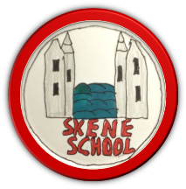

**High Quality Learning and Teaching**

* **Clear Learning Intentions and Success Criteria linked directly to E’s and O’s**
* **AifL Strategies are embedded**
* **Staff use technology to enhance learning**
* **Pupils are reflective**
* **Pupils receive and enjoy challenge in their learning**
* **Transition procedures ensure progression**
* **Staff professional development makes a difference**
* **Assessment is learning to reach full potential**
* **Opportunities for all**
* **Support and challenge planned for accordingly**

**Ethos and Life of the school as a Community**

Pupil Voice is a priority for driving school developments forward.

Every child and member of staff is part of a curricular club (Community Carousel)

Excellent Community Links and partnership working with all stakeholders

Shared through Assemblies, newsletters, Book Creators and school website.

National Priorities

Improvement in attainment, particularly Numeracy and Literacy.

Closing the attainment gap between the most and least disadvantaged children.

Improvement in children and young people’s Health and Wellbeing

Improvement in employability skills and sustained positive school leaver destinations for all young people.

**What are the drivers of our curriculum?**

Ensuring high quality Learning and Teaching is at the heart of all that we do.

Treating each learner as an individual to help them reach their potential.

Relationships built on mutual trust and respect.

**What makes us unique?**

Skene School nurtures each child as an individual, providing challenge and support for everyone. Our School is at the heart of the community and our unique geographical setting allows us to thrive in an excellent learning environment. All pupils and staff strive to do their best and always have a growth mindset.

The 7 Design Principles

Relevance

Challenge and Enjoyment

Depth

Coherence

Breadth

Personalisation and Choice

Progression