Skene School Bulletin 3 29.04.16
Working Together, Learning Together, To Be The Best We Can Be
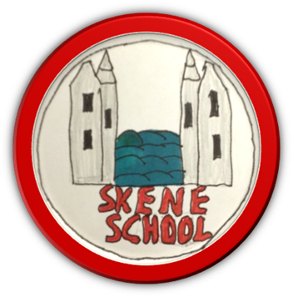
Welcome back to school after the Spring Break. It sounds like everyone had a great time, parents too I hope. What a busy term that lies ahead for us all from sports day to summer shows and transition to Leaver’s Assemblies. We have set off to a flying start with our Vision Re-launch Week last week. There are more details below but be sure to ask your child/children what we were doing. As always, please don’t hesitate to get in touch if you have any questions/queries.

Miss Hampton
Class News…
By Kate: In P1/2 we have been writing about our Easter Holidays. We have been trying to show off our best writing. My favourite activity from the Vision Re-launch week was learning the vision and then designing a book mark with it on it. We really enjoyed showing our mummies and daddies our work on the Open Evening.

By Isla and Karly: In P3/4/5 we have been doing some work around Talking Partners. We have been looking at the rules that we will use for this and we have been learning different ways that we can greet each other. So far, we each have a speech bubble filled with information to help us find a new talking partner. We enjoyed doing lots of activities for the vision re-launch week. My favourite was making a poster to show what behaviours link to each of our values.

By Eryn: In P5/6/7 we have a new topic which is ‘Extreme Weather.’ We have shared our ideas of what we would like to find out about throughout the term. We were learning about algebra in Maths – it was fun! The Vision Re-launch week was really fun. My favourite activity was creating book marks and postcards to share with our visitors and to use as invitations. It will help get our school known in the community. ‘Porridge’ is the name of the show that we will be doing at the end of term.

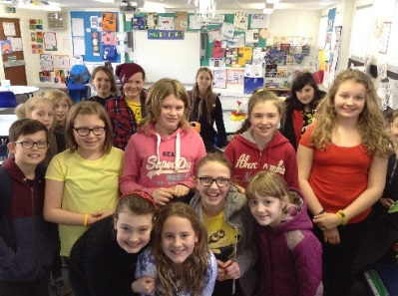
Archie in Africa Charity Day
On Friday 1st April, we had a charity day to raise money for Archie in Africa. Our Charity Champions organised and led a very successful day. Here is a selection of highlights from the day…

Come dressed in the colours of the Ugandan flag – yellow, black and red
What a colourful school we had today! It was great to see bright colours and smiling faces. Thank you all for getting into the spirit of the day and wearing these colours.

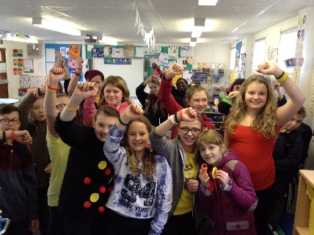
Archie in Africa Wristbands
The wristbands proved very popular and we even sold out! Everybody got to buy at least one, if not two.

Assembly with Professor George Youngson
After break we had an Assembly with Professor George Youngson. He was a surgeon at the Royal Aberdeen Children’s Hospital and now that he is retired, supports the work of Archie, both here in Aberdeenshire and in Africa. George was able to share his first hand experiences of Uganda and also inform us what the money we had raised would go towards. Be sure to ask the children…

Total raised…
A very big thank you to everyone who donated in any way. The Charity Champions counted up our money and we raised a fantastic… £137.64. We will ensure this money gets sent off straight away.

Holiday Transformations…
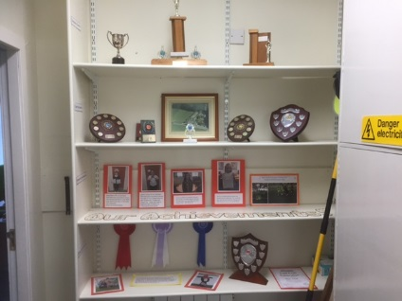
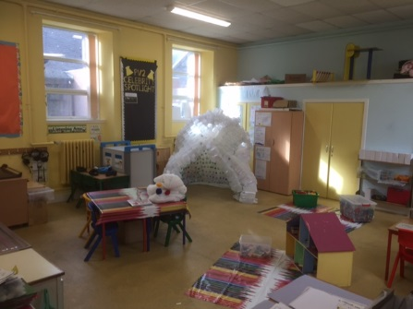
As you may have heard we had a good clear out at school over the holidays filling 2 skips and 2 trailers also. The learning environment is now much improved and we look forward to focusing on the Learning and Teaching from now on. The children have been raving about the new look of our school and I am sure you will notice a difference when you are in also.

My thanks go to Mrs Milne, Miss Bruce and The Munro family for all of their help. A very special thank you to Miss Law who gave up ‘too much’ of her holiday to help me out also. I could not have achieved this without all of this help.

Open Evening
Thank you very much to those of you who managed to come along to our Open Evening on 30th April. It was great to see so many of you and share our successes and achievements. We hope you liked the Book Creator App on the iPAD as this is something we are hoping to use consistently throughout the year.

Homework Policy
As you will know there was an opportunity at the Open Evening to share your views about homework. We gathered views from a sample of all of our stakeholders including parents, children and staff. Please find the summary attached to this email and the new proposed Homework Policy. Please note that decisions were made based on the findings from the questionnaire and we went on the majority for each.

The staff and I would really encourage you all to sign each piece of homework to acknowledge that you have seen it. It is important that we all work together to ensure high levels of effort and presentation.

The Class Newsletters mentioned in the action plan were distributed on Monday (25.04). I hope these help to give an overview of the term and how you can further support your child at home.

Skene School Policies
In order to reinforce all of our policies and keep parents up-to-date and informed about what is going on in school, we will be emailing out one policy a week to Parents. I will also upload them to the website.

Vision Re-launch Week
What a fantastic week we have had. We re-launched the School Vision which was updated a few years ago:
Working Together, Learning Together, To Be The Best We Can
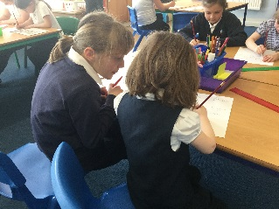
We also revised the Values and merged some of them together to help us remember them. For each one we created a set of behaviours and expectations – we kept all of the ideas from the original list, we just reorganised them. They now come under 5 main headings:
- Being Safe
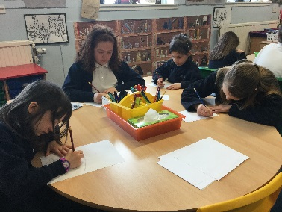
- Can Do Attitude/Growth Mindset
- Opportunities for all
- Partnership Working
- Respect for Everyone
We have learned about the 4 capacities and what it looks like, sounds like and feels like to be a Confident Individual, Effective Contributor, Responsible Citizen and a Successful Learner. We displayed these in creative ways and as a jigsaw!
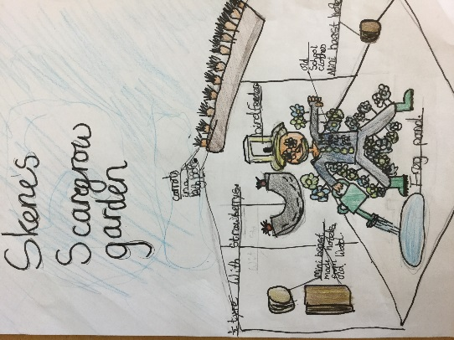
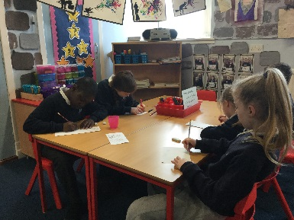
We also took part in the One Planet Picnic Garden Competition. On Monday, every pupils shared their ideas of how we could create a garden using recycled materials, show a welcoming environment for mini-beasts and bugs and have a link to our local area! The children came up with some fantastic ideas before Mrs Robb kindly merged one of them together and created a digital plan for us. Scarlett confidently shared this at an Assembly and drew our entry, labelling it clearly. Our garden is called ‘Skene’s Scare-grow Garden.’ Can you guess from the name what one of the main features is? We should hear by next Friday whether we have progressed to the next round. A very big thank you to Mrs Robb for all of her help so far.
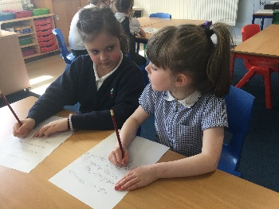
Throughout the week we have worked in cross stage groups and with all of the different teachers. It has been a fun and busy week.
Each class has captured key moments from the week in a Vision Video. Hopefully we can share these with you very soon.
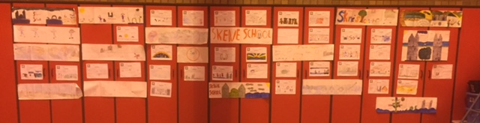
We would like to paint a mural on the red cupboards at the back of the Gym Hall to brighten it up and show what Skene School/Community means to us. The children have provided excellent designs and now Mrs Cooper, Art Teacher, is working hard to produce the final design – taking bits from all designs. It is our aim that every child and member of staff will be part of the painting process. We have written to B&Q to ask if they can help provide tester pots of paints which we will use to paint it. Please let us know if your child has ever had a reaction to this or if you would prefer them not to use it. We will let you know what dates we are painting and will ask you to send in some old clothes for the children to wear.
Reports
All reports were handed last Friday. Class teachers wrote the majority of the content with Visiting Specialists adding comments for their own subject. Mrs Moorhouse, Support for Learning, has also provided individual/group comments for the children that she works with.

You should have found a letter inviting you to an optional Parents Evening. Thank you for the replies we have time. Time slots will be sent on Tuesday 3rd May. There will be several opportunities for you to share your child’s learning throughout the term including Snapshot jotters (a week of work in one jotter to take home and share), Book Creator Apps etc.
Netball and Football Festivals
Our School Netball and Football teams have a very busy period ahead with lots of fun festivals. Please keep coaches informed of your availability. We are hosting a Netball Festival at Skene School on Tuesday 24th May. A big thank you to Ann Buckett, Julie Constable and Julie Forbes for organising this. Good luck to everyone in the forthcoming events and enjoy!

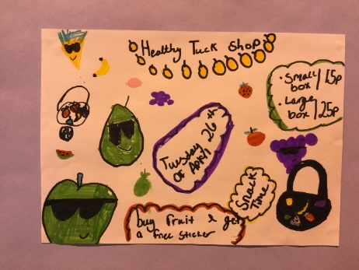
Healthy Tuck Shop
The Healthy Heroes organised a Healthy Tuck shop on Tuesday, 26th April. It was very successful and enjoyed by all. Thank you for supporting this.

Parent Council
A very big thank you to the Parent Council who have just purchased a further 21 iPAD’s and cases for the school. This is a fantastic learning opportunity for us now that we have at least one iPAD between 2 children. The digital literacy skills is a strength for the school and we will continue to embed them as we work.
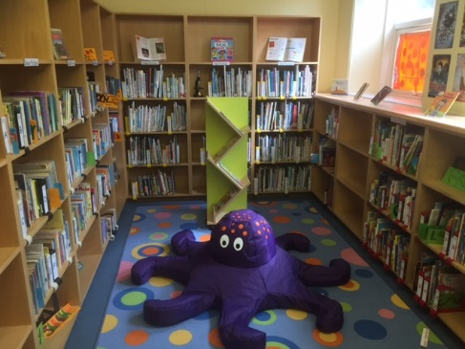
The library has been redesigned and looks fantastic! A BIG thank you to all of the parents and staff who helped in the process. Thank you also to the Parent Council for funding some new furniture and book stands – we are just waiting for one more piece of furniture to arrive. Pictures will follow but here is a sneak peak...

We now have a magazine stand in the Library. With the cost of magazines nowadays it will be hard for us to main an up-to-date selection in the library. Please, if you purchase magazines, consider handing them into school when you are finished with them instead of recycling them or throwing them out. This will help us keep our stocks up and fresh.

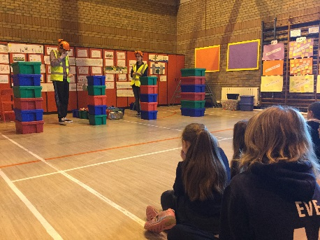
Generation Science
We had a visit from Generation Science on Tuesday 26th April for pupils in P3-7. Pupils were learning about renewable energy and fossil fuels. The pupils and staff really enjoyed it. The company will return on Thursday 26th May to visit P1/2.

A few reminders…
- Please ensure that your child has a jacket with them every day. As you know, the weather can change quickly and we will go outside in most weathers.
- A reminder that every child requires a pair of indoor shoes every day. The Parent Council kindly purchased shoe boxes for each child so these can be stored safely every night.
- Please return scratch cards and relevant monies as soon as possible. Our Parent Council work hard to support the school and the money raised will go to purchasing more technology, library developments and playground equipment.
- The next Parent Council Meeting is on Tuesday, 26th April at 7pm. All welcome.
- The whole school walk up Bennachie is on Saturday 21st May. We hope to see as many of you there as possible. Remember to ask family and friends for sponsors.
Classes for next session 2016/17
As you can see from the dates below, we are beginning to think about transition. Please note the dates for stepping up afternoons as these are for the whole school. We have chosen these dates as they suit the needs of the school – the majority of our P7 year group are away at Barcaple making it easier to move all year groups on with the least amount of disruption.

We will inform pupils and parents of the class set up and their teachers on Monday 6th June but please not they will be subject to change should the school role change before term starts on August 15th. Please respect this decision and know that meeting individual pupil needs is at the heart of the process.

Dates for your Diary:
- Friday 22nd April – Reports out to Parents and invitations for Parents Evening
- Tuesday 26th April – Generation Science visit for P3-7 pupils,
- Parent Council Meeting 7pm
- Wednesday 27th April – P7 Barcaple Trip Meeting at Crombie Primary, 6pm
- Friday 29th April – P5 Swimming Lessons, 9:30-10:30am
- Monday 2nd May – May Day Holiday
- Tuesday 3rd May – Kirkton of Skene Playgroup Visit
- Parent Evening time slots handed out
- Friday 6th May – P5 Swimming Lessons, 9:30-10:30am
- Monday 9th May – Hedwig to visit P3/4/5
- Thursday 12th May – Parents Evening (optional)
- Friday 13th May – P5 Swimming Lessons, 9:30-10:30am
- Friday 13th May – P6/7 Sailing Taster Session at Loch of Skene 10-12pm
- Tuesday 17th May – Kirkton of Skene Playground Visit
- Friday 20th May – P5 Swimming Lessons, 9:30-10:30am
- Saturday 21st May – Bennachie Sponsored Walk, 10am at the Rowan Tree Car Park
- Tuesday 24th May – Parent Information Session/Training for Bikeability, 10-12pm
– Netball festival at Skene School 4 – 6/6:30pm
- Thursday 26th May – Generation Science visit for P1/2 pupils, 2-3pm
- Tuesday 31st May – Parent Council Meeting, 6pm
- 1st/2nd/3rd June – Bikeability for P5/6
- Monday 6th June – Friday 10th June – P7 Barcaple Residential Trip
- Bikeability for P5/6
- Tuesday 7th June – Stepping Up Afternoon
- Wednesday 8th June – Stepping Up Morning followed by P1 Parents Lunch
- Thursday 9th June – Stepping Up Afternoon (including P1 Coffee Afternoon)
- Tuesday 14th June – P7-S1 Sports Transition Day
- Friday 17th June – Sports Day and Parent Council Fun Day
- Friday 24th June – Back up date for Sports Day
- Tuesday 28th June – Dress rehearsal for End of term P7 show
- Wednesday 29th June – End of term P7 show, 6 for 6:30pm
- Friday 1st July – Last day of term – Leavers Assembly to be held at the Church at 2pm. All welcome.

