Skene School Bulletin 24.03.16
Working Together, Learning Together, To Be The Best We Can Be

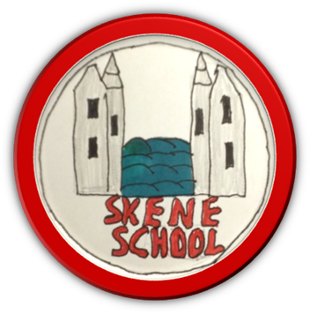
Hello everybody and Happy Easter!

It is hard to believe that we have almost reached the end of term 3 and the end of March already. Where does time go?! It has been another busy time for us all at Skene School and here are some snapshots for you to share as well as some important dates to note.

When the time comes, I wish you all a happy and safe Spring break.
Miss Hampton

Classroom updates from our Budding Broadcasters…
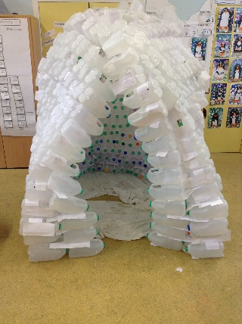
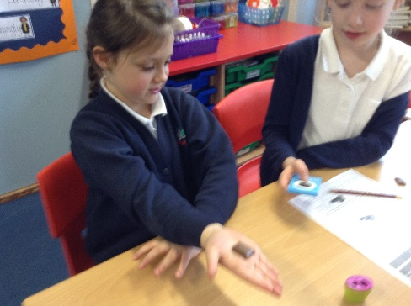
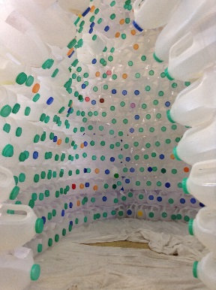
In P1/2 we have been learning about Polar Bears. We know that they have fur and black skin underneath it even though they look white! In Maths, we have been doing addition and subtraction sums and also exploring the 2 and 4 timetables. We have been writing Book Reviews for our Reading Books. In RME, we have been learning about the Easter Story. We are very excited to tell you that our igloo is finished! We are looking forward to sharing our work with your next week at the Open Evening.

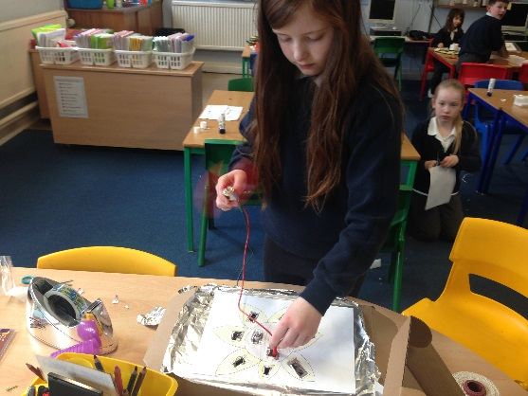
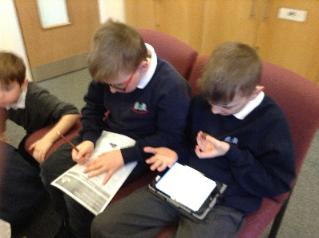
We have been very busy in P3/4/5. In our topic work we have been exploring Diagon Alley. We have created our own version of this on the wall. We also made maps linked to it. In Maths we have been learning about probability. It is the chance something will happen. We were also reading block charts and creating our own favourite flavor of bean. In literacy we were learning about features of a poster. We designed one for our shop.
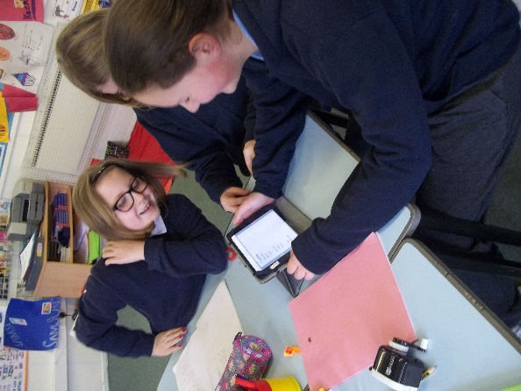
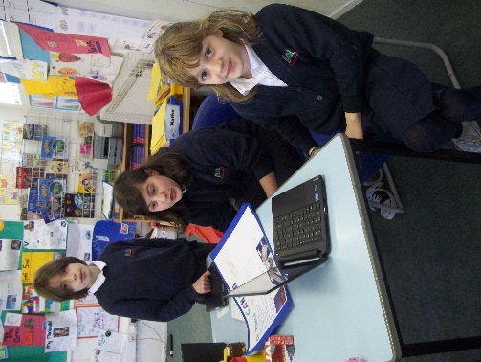
P5/6/7 have been working very hard. The primary 7’s have been doing Play Leader training. It was fun and we all passed. We have been helping the primary 1 & 2 make a book on an awesome app called Book Creator on the iPad. We have made our own ones too which we will show you at the Open Evening. As part of our work for World Book Day, we learned all about education around the world and how fortunate we are. In Maths, we have been doing sequences and now we have moved onto algebra. It is really fun and it gets our brains working. In Science we are learning about the different types of farms. Once we have completed our research we are delivering lessons to the whole class. In PE, Miss Hampton has been teaching us club golf and Mr Strachan has been teaching us Gymnastics.
On-line Payment System for Lunches
The new dinner system is working well. We did have a few technical glitches at the start however most of these appear to have been ironed out. We are aware of a couple of families still having issues with the on-line payments – these have been reported to the relevant person.

A new menu for next term will come home in school bags today. Please look out for this. It will start on Monday 18th April.

P7 Rotary Quiz
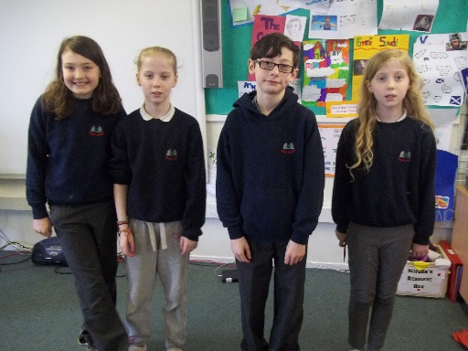
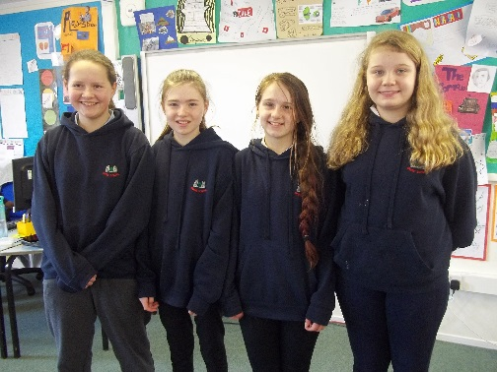
Very well done to both of our teams that took part in the Rotary Quiz on Tuesday 1st March. The children did themselves and the school proud and tried their best with some very challenging questions.

Play Leader Training
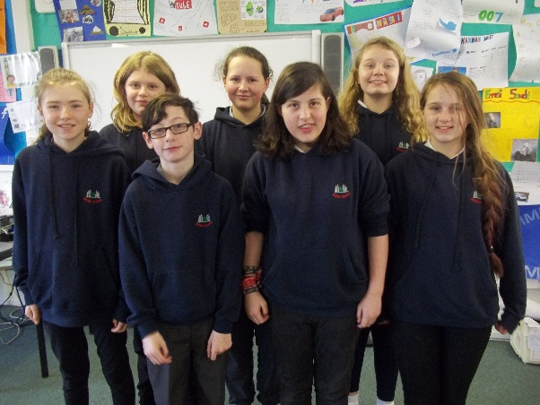
All Primary 7 pupils did their Play Leader Training and I am very happy to say that they were all successful with the assessment. We have created a Play Leader rota which will start on Monday 18th April. Play Leaders will facilitate games and social opportunities for the P1-3 pupils. They will be easily identified with their bright yellow hoodies – thank you to the Parent Council for funding these.

Learner’s as Leaders
We want to keep you informed about the pupil priorities within the school.
- Playground Pals – We have introduced a new system for knowing whether we are allowed on the pitch or not. It is working well. We have also started a litter picking rota to help keep our school environment clean.
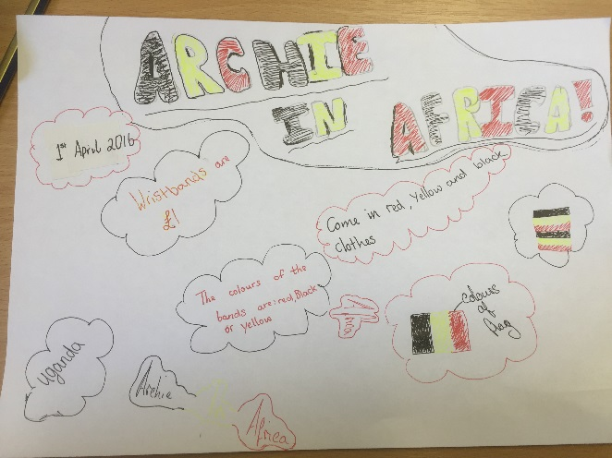
- Concerned Councillors – We have introduced a new bus system with red/yellow cards. We are working with Miss Hampton to develop the school library and we are looking at how we can enhance Reward Time to have a skills focus.
- Charity Champions – We are organising a charity day next Friday, 1st April for ‘Archie in Africa’. We would like everyone to come to school dressed in the colours of the Ugandan flag – yellow, red and black. If you do, we ask that you bring a donation for the charity. You can wear one colour or all colours. We will be selling Archie in Africa wrist bands for £1.

Club Golf
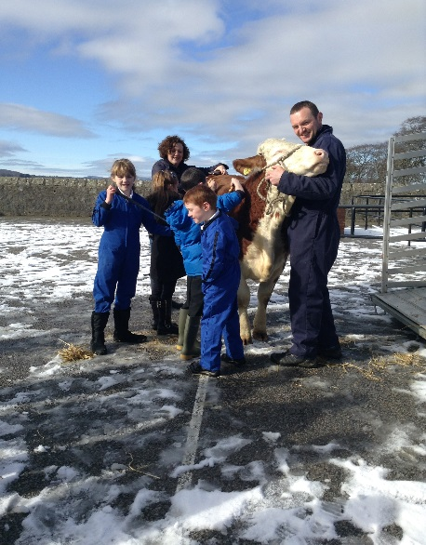
All pupils in P5-7 have been participating in the Club Golf Programme. They have been developing skills in launching (driving), chipping and rolling (putting). We were very lucky to be joined by Joyce Boyd from Westhill Golf Club during one of our sessions.

Calf Visit
Following on from our lamb visit last month, we welcomed ‘Tarka’ the calf to school on Monday 7th March. This was an opportunity for the children to learn more about our local environment and share with the roles and responsibilities that some of our pupils have out with school. Thank you to Mr and Mrs Munro for giving up their time to allow us this opportunity.
ChildLine
On Friday 11th March we welcomed Linda from ChildLine to school. She did an assembly for the whole school about ‘A Bag of Worries’ and a workshop for our P6/7 pupils about anxieties and worries and possible strategies that they could employ to help.

Assembly challenges
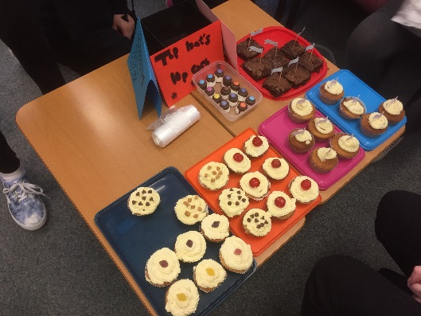
Following our Assembly with Ms Stewart about Lent and kindness, we have been completing kindness challenges. Thank you to those who have sent photos in – they are in our Scrapbook at reception.

Well done to Eve (P7), Kara (P7), Freya (P6) and Sarah (P6) for organising a Cake and Bake Sale for the staff. We enjoyed a selection of delicious goodies and raised £20 for the charity ‘Step Ahead.’ A big thank you from all of the staff.
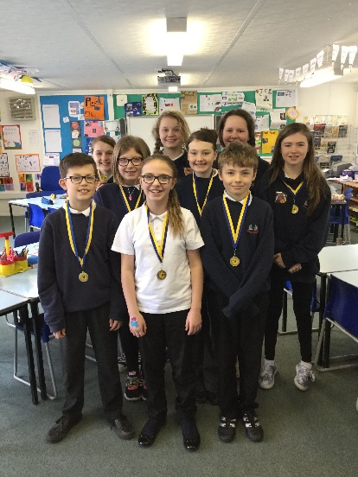
Around the World in Music
9 of our pupils in Primary 5-7 participated in the Rotary event ‘Around the World in Music’ on Sunday 13th March. The children sang three songs as part of the Westhill Schools Choir – ‘A-roving’, ‘Someone like you’ and ‘Highland Cathedral’. Thank you to Miss Robertson, our music teacher, for coordinating the event and to Mrs Wilkie and Mrs Buckett for supervising the children on the day.

Active Schools
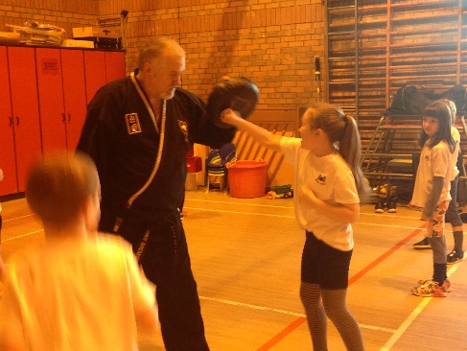
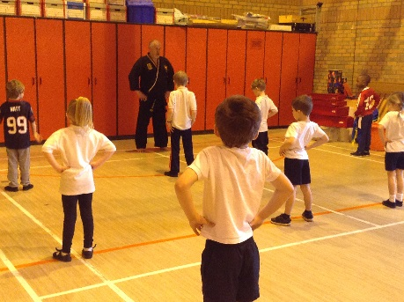
P1/2 and P3/4/5 have enjoyed a taster session of Sooyang Do with Dave Bremner. This was arranged by our Active Schools Coordinator. Information will be coming home about local opportunities to pursue this, if interested.
Primary 5 pupils will participate in swimming lessons after the holidays starting on Friday 29th April.

Sailing
Our P6 and 7 pupils will have a Sailing taster session on Friday 13th March at Loch of Skene. Again, thanks to the Parent Council for funding this. It will become an annual event for our P6 year group.
Parent Council
We had a very successful meeting on Tuesday 8th March with lots of exciting events in the pipeline. Please find attached minutes of the meeting. A big thank you to the Parent Council for your continued support.

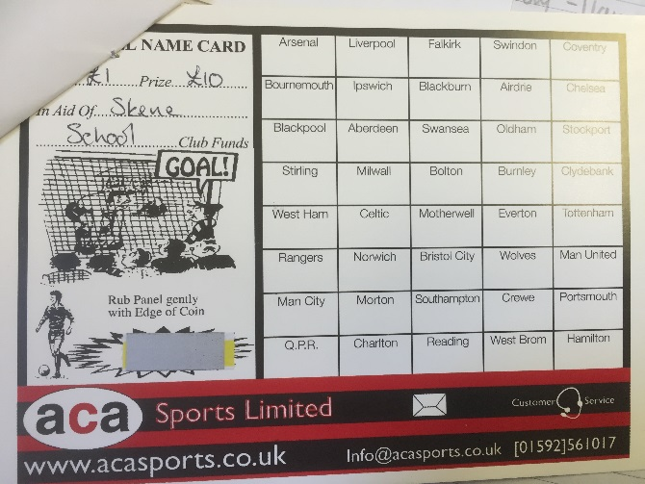
The Parent Council continue to fundraise in order to support the school and pupil learning. I would really encourage all families to support any fundraising activities as much as they can. Without the additional funds from the Parent Council, we would not be able to provide all of the experiences and technology opportunities that we do.

Scratch cards should have come home with the oldest and only child in each family yesterday. Please see the accompanying note for more information.

Education City
Education City is a tool that we use in school to support class work and consolidate skills and knowledge. We enjoyed a trail of Education City for home access and I thank you for the feedback received to date. If you have any comments to feedback, please let me know by phone or email before next Friday.
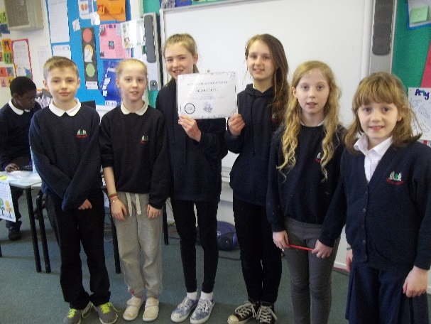
Cluny Netball Fun Day
Well done to all of those who took part in the day. There were friendly matches and knockout stages. Everyone played well and we finished third.

Chess
Congratulations to Ollie Killman who is our Skene School Chess Champion. After a closely fought final against Kara Buckett, Ollie secured the win. Well done to both pupils and a big thank you to Mr Rodgers who has given up his own time to provide this opportunity for our pupils.

Bikeability
In a recent email I let you know that we are making some changes to the Bikeability format in school. We will now provide this opportunity for pupils in Primary 5 and 6 every two years. Thank you to those parents who have responded and offered their help with the sessions. We almost have them all covered – please, if you have not responded and you can offer any support, get in touch.

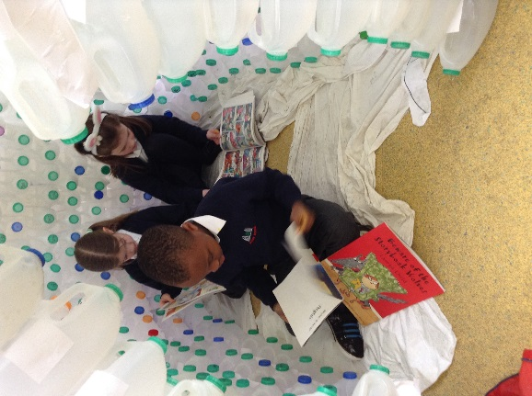
Library
Our Concerned Councillors have identified the school library as an area that requires immediate attention. I sent an email out yesterday asking for any help next week to rearrange the books as we have been guided by Aberdeenshire Library Services. Please let me know by phone or email if you can offer any help.

Easter Celebrations

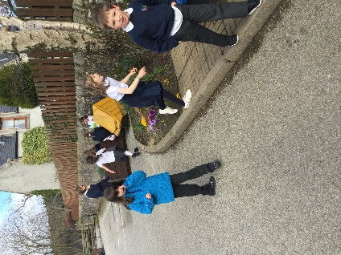
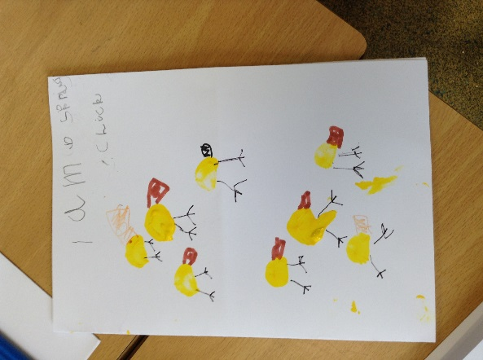
What a super day we have had today. This morning we had our Easter Assembly at Skene Church which was led by the Primary 6 and 7 pupils. P1/2 performed their ‘Spring Chicken’ song with lots of enthusiasm and we had two further songs which were performed beautifully. Thank you to everyone who came along to celebrate with us – it was great to see so many of you.

Classes have been learning about the Easter story and doing some related crafts.
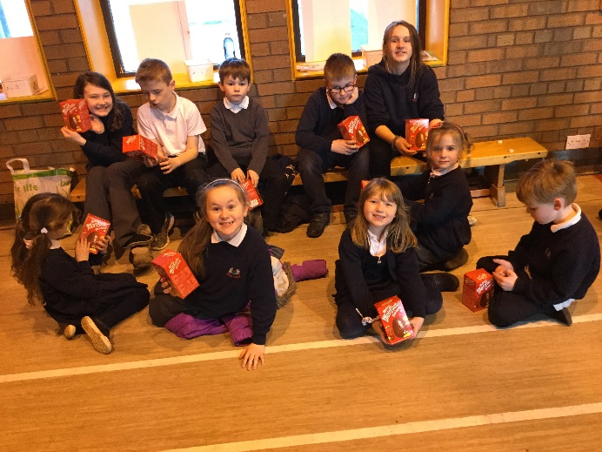
This afternoon we had a whole school Easter Surprise – in mixed teams from P1-7, the children hunted for coloured eggs which revealed parts of the Easter Story. Once they had pieced it all together and sequenced it correctly, they received a prize. Thank you to the Parent Council for providing the Easter eggs. It was great to see everyone working together – a real team ethos!
Looking ahead to next year…
I visited Skene Playgroup on Tuesday 22nd March and met some of our new P1 pupils for August. We had great fun playing together and getting to know each other. We have arranged two opportunities for the playgroup to come along to school and work with us. The dates for these are Tuesday 3rd May and Tuesday 17th May. This is prior to the stepping-up visits.

Please note that class configurations will not be made until well into term 4. We are awaiting information about and confirmation of numbers for our P1 intake and must have this before we can consider class set ups. Please respect that we will inform you as soon as we have made final decisions and allow us the time to do this to ensure we consider all relevant information.

Dates for your Diary
A full list of dates can be found on the website for the remainder of the year. Please see key dates for the remainder of Term 3 and for Term 4 below.
- Friday 25th March – Good Friday Holiday
- Wednesday 30th March – Open Evening, 3:15 – 4pm and 5:15 – 6pm
- Friday 1st April – ‘Archie in Africa’ Day and last day of term
- Monday 18th April – School returns for pupils and staff
- Friday 22nd April – Reports out to Parents and invitations for Parents Evening
- Tuesday 26th April – Generation Science visit for P3-7 pupils
- Friday 29th April – P5 Swimming Lessons, 9:30-10:30am
- Monday 2nd May – May Day Holiday
- Friday 6th May – P5 Swimming Lessons, 9:30-10:30am
- Monday 9th May – Hedwig to visit P3/4/5
- Tuesday 10th May – P1 Induction Evening
- Thursday 12th May – Parents Evening (optional)
- Friday 13th May – P5 Swimming Lessons, 9:30-10:30am
- Friday 13th May – P6/7 Sailing Taster Session at Loch of Skene 10-12pm
- Friday 20th May – P5 Swimming Lessons, 9:30-10:30am
- Tuesday 24th May – Parent Information Session/Training for Bikeability, 10-12pm
- Tuesday 24th May – Netball festival at Skene School
- Thursday 26th May – Generation Science visit for P1/2 pupils, 2-3pm
- 1st/2nd/3rd June – Bikeability for P5/6
- Monday 6th June – Friday 10th June – P7 Barcaple Residential Trip
- 6th/7th/8th/9th/10th – Bikeability for P5/6
- Tuesday 14th June – P7-S1 Sports Transition Day
- Friday 17th June – Sports Day and Parent Council Fun Day
- Friday 24th June – Back up date for Sports Day
- Tuesday 28th June – Dress rehearsal for End of term P7 show (tbc)
- Wednesday 29th June – End of term P7 show, 6 for 6:30pm (tbc)
- Friday 1st July – Last day of term – Leavers Assembly to be held at the Church at 2pm. All welcome.

