Skene School Bulletin 26.02.16
Working Together, Learning Together, To Be The Best We Can Be
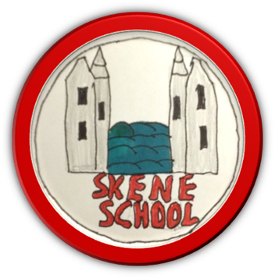
A message from Miss Hampton…

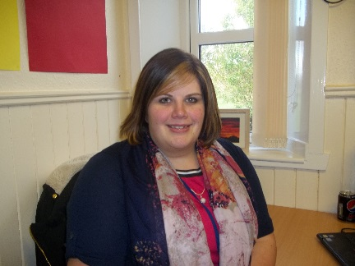

Welcome to our February Bulletin, bringing you the latest news, successes and reminders from Skene School.

A personal thank you for the very warm welcome I have received from you all. It is has been great to meet so many of you already and for those I haven’t, I hope to meet you soon. Please note that I have an open door policy and welcome you getting in touch when necessary. We have had a very positive four weeks and there has been lots happening. Please enjoy sharing our successes in the following pages…

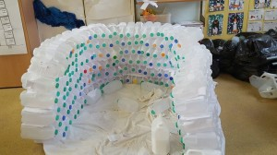
Miss Hampton

In the classrooms… a review from our Budding Broadcasters

P1/2 by Kate
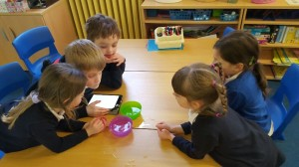
Our topic in Primary 1/2 is Winter Wonderland. We have been learning lots about penguins by asking lots of questions. We are building an igloo in the classroom which will be big enough for 3 or 4 people to go in. It is great fun and we are trying to work out how to make the curved section at the top just now. We have been doing Number work in Maths and learning some of the times tables. We have been doing lots of science experiments about water. My favourite was the ice experiment. We had one bowl of plain and one with salt water. We had to guess which would melt the ice first. It was fun to time it with the IPAD.
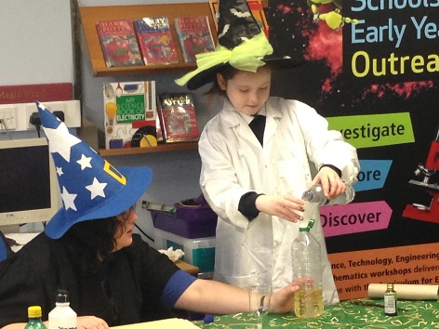
P3/4/5 by Struan K
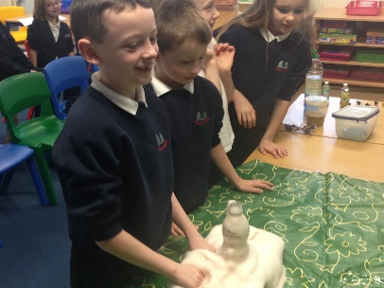
In P3/4/5 our topic is Harry Potter and we have turned our classroom into Hogwarts School. This week we received letters from Professor McGonagall inviting us to visit. We have to reply and explain if we would like to come or not and you can say what you will be taking with you if you want. We loved our TechFest visit – we made elephant’s toothpaste and exploding rockets! We have been learning how to divide in Maths. We have just finished our Harry Potter stories in Writing and look forward to sharing them soon.

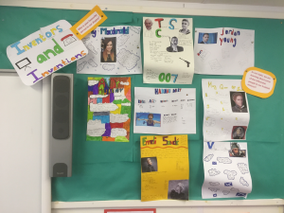
P5/6/7 by Erin
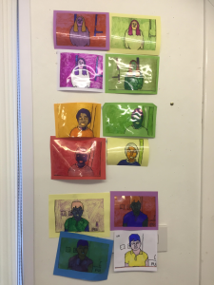
We have been learning about weight and measure in Maths, making links to our local environment by thinking about how much animals weigh. Our topic is Influential Inventors and Inventions. We selected a Scottish Inventor and researched all about them before sharing our findings in a talk. This week we have been exploring more modern inventions which are influencing our lives today e.g. social media and medical advances. Last Friday we had a visit from TechFest. We explored the world through Maths and had to problem solve our way into a labyrinth. In Art, we have been looking at Andy Warhall’s work and thinking about how he has influenced History through pop art. Our class novel is The Lily-Livered Prince – we are now exploring an artist related to a popular scene from the book!

Leadership
I am keen to develop leadership skills for our pupils. We have introduced several roles/posts throughout the school as follows…

Concerned Councillors | A group forming to be the Pupil Council. The group will work closely with the Parent Council, sharing their ideas for development and gathering information to represent the views of all pupils.
Playground Pals | A working group to improve the playground - looking at ways to share information between pupils and staff, indoor and outdoor breaks, zoning etc. Also working with the Parent Council with regards to equipment.
Charity Champions | A focus group looking at possible charities and fundraising events that we can become involved with.
Website Whizz | Responsible for updating the information in their class section of the website – information and photographs.
Budding Broadcaster | Responsible for sharing information about what has been happening in their class for the Skene School Bulletins – information and photographs.
Play Leaders | An opportunity for all P7 pupils to organise and implement games in the playground for our younger pupils. Training will be provided very soon and a rota put in place.
Per year group Per class P7 only
Community Carousel
On Monday, we introduced a Community Carousel – an opportunity for all pupils to be involved with key developmentsn the school. We have four groups, each lead by one of our teachers. Pupils from P1-7 will work in cross-stage groups.

Name of Group | Group lead by…
Bear Grylls (Outdoor Learning) | Miss Law
Eco Warriors (Eco Schools Award) | Miss Ratcliffe
Healthy Heroes (Health Promoting Schools) | Miss Bruce
Rights Rockers (Rights Respecting School Award) | Miss Hampton

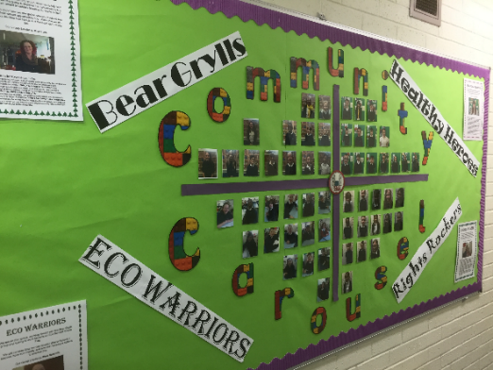
We will work on a 4 week cycle, three weeks will be working groups and the fourth week will be a sharing session so everyone is aware of what is happening in school. We will also take the opportunity to share this with parents in a separate newsletter. It is our aim that next session, 2016-17, the children will rotate around all four groups in the year, moving around each term.

World Book Day
You should all have received an information leaflet, by email or in your child’s school bag about World Book Day 2016. This is taking place on Thursday 3rd March 2016. There will be a variety of activities and opportunities for the pupils to get involved with throughout the day. We are also asking that all pupils and staff come to school dressed as a character from a book/their favourite book. We look forward to celebrating this day with everyone.

Information Gathering
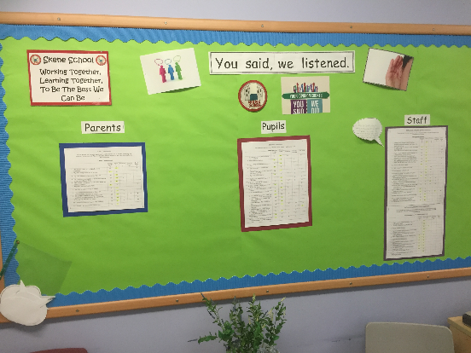
Thank you very much for taking the time to complete the parent questionnaires I distributed. It is very helpful to hear the parent voice. I have collated all of the information and have created an action plan based on this. I will strive to address all of the areas highlighted within the feedback.

Website
Please access the School Website as a method of sharing information, news and successes. It has been recently updated and I will strive to maintain this on a weekly basis with the help of our Website Whizzes. The address is:
http://skene.aberdeenshire.sch.uk/

Reports/Parents Evening
The class teachers are busy writing your child/children’s annual report. These will be handed out on Friday 22nd April. A letter for Parents Evening will be included in the envelope. Parents Evening is scheduled for Thursday 12th May. This is an optional meeting, should you wish to discuss any of the content of the report/your child’s progress. We will ensure appointment times are handed out with sufficient notice.

Sporting News/Active Schools
- Netball training continues on a Tuesday after school. The team played in the Netball Festival at Westhill Academy on Tuesday evening. Well done do all who took part.
- Football training restarted on Tuesday 9th February. There is a slight change to the format of the sessions as there is now only one session for all ages between 4.40 and 5.30pm, straight after netball.
- Well done to all pupils who took part in the cross country event on Thursday afternoon. Congratulations to Innes Munro for winning 1st place in the P5 Girls Race and Kara Buckett for coming 3rd in the P7 Girls Race.

I would like to extend my thanks to all parents who give up their time to put on these opportunities for our pupils. Your time and effort is very much appreciated. Thank you.

I recently met with Anna Thorburn, our Active Schools Coordinator, and am pleased to let you know that there are many exciting opportunities coming up including Sooyang Do taster sessions for P1/2 and P3/4/5, swimming lessons for our P5 pupils and Club Golf for P5/6/7. More information to follow.

Parent Council
The Parent Council held a very successful Burns Supper at the Ashdale Hall on Saturday 6th February. A big thank you to the Parent Council for organising this event and for their continued hard work. Also, special thanks go to:
- Anne for giving up her lunchtimes to organise the highland dancing.
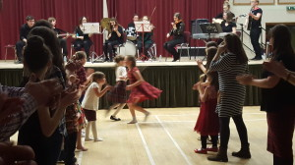
- Andy for compering the evening and singing with the children.
- Julie Wilkie for doing the shopping, sorting the finances and organising the piper.
- Garlogie for providing the delicious food.
- The Westhill Academy Ceilidh Band and Rhonda Pirie and Miss Davidson for helping with the violin players.
- The School Staff for helping with the Doric poems and singing.
- Mr Strachan, PE Specialist, for teaching the children a selection of Scottish Country Dances.
The next Parent Council Meeting is on Tuesday 8th March at 7pm.

Reminders – PE kits
Just a couple of reminders, please and I would appreciate it if you could reinforce these with the children.
- The system for purchasing dinner tickets is changing and you should have all of this information by now. It is an on-line system designed to reduce paper and the handling of money in the kitchen. If you have any questions, please get in touch. All schools in the Westhill Cluster go live on Monday 29th February.
- The kitchen staff and I have noticed that some children have been swapping items in their lunch boxes and buying tuck shop and juice for others. We will not allow this as we feel parents should know what their child is having each day.
- All children should have a PE kit at school. Each class has at least 2 PE slots a week. There is an increasing number of children turning up to lessons without the appropriate kit.
- All children should have indoor shoes to change into when they come in from the playground.
- The lost property pile is ever increasing. Please make sure all clothes and shoes are clearly labelled.
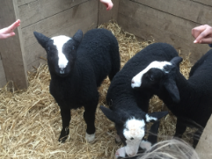
Community Links
On Friday 19th February we had a visit from Mr Wilkie and 4 of his lambs. P5/6/7 arranged the visit and P1/2 managed to pop out for a quick visit too. It was great to see Faye (P7) and her Dad, Mr Wilkie, on TV on a recent episode of ‘The Mart’ – a great way to highlight our local community. A big thank you for coming to school and sharing your experiences and knowledge with us.

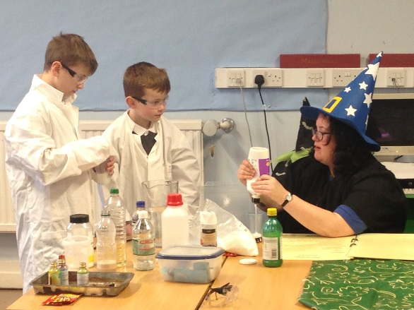

Also on Friday 19th, we had a visit from TechFest. Each class enjoyed a session with topics such as ‘TechFest Tales’, ‘Spooky Science’ and ‘Maths Around the World.’ All of the children appeared to have a great time, engaging well and learning lots. It was great to have such good feedback from the provider at the end of the day. Well done, everyone!

Dates for your Diary
A full list of dates can be found on the website for the remainder of the year. Please see key dates for Term 3 below.
- Monday 29th February – ‘Go Live’ for on-line payments for school lunches
- Tuesday 1st March – P7 Rotary Quiz, 7pm
- Thursday 3rd March – World Book Day 2016
- Tuesday 8th March – Parent Council Meeting, 7pm
- Friday 11th March – ChildLine Visit for P6/7 pupils
- Sunday 13th March – ‘Around the World’ Music Event at the Ashdale Hall, 2:30pm
- Thursday 24th March – Whole School Easter Egg Hunt
- Friday 25th March – Good Friday Holiday
- Wednesday 30th March – Open Evening (more details including times to follow)
- Thursday 31st March – End of term Assembly lead by Reverend Stella, 9:20am
- Friday 1st April – Last day of term

