Term 1
P1/2
Skene School

Welcome back to school, I hope you all had a great summer and enjoyed the beautiful weather. The primary 1’s are all settling in well and we are looking forward to having them here for full school days.
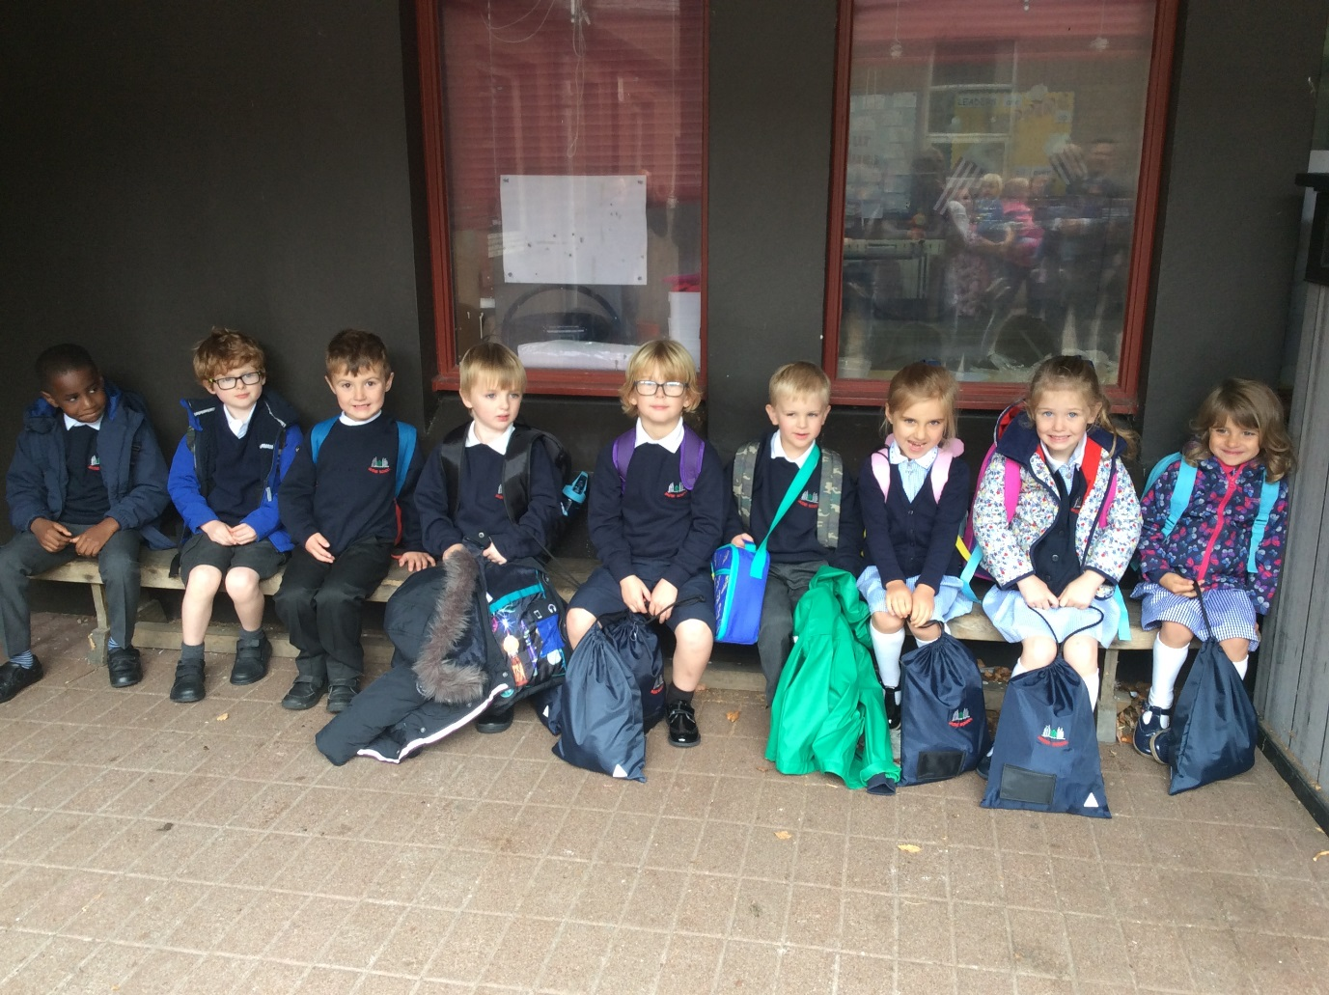
Timetable
Monday – PE with Mrs Smart (outside when possible)
Monday – Library
Wednesday – PE with Miss Bruce
(Please ensure PE kits are in school on Monday and Wednesday.)
Thursday – Mrs Smart in class
Homework
Homework will be given out on a Monday and due back to school on a Friday. Please ensure that the homework is signed.
Reading will be heard in class and we ask that you practise reading at home. We ask that you sign and date the reading record.

Other Curricular Areas

Our class topic for this term is Mini-beasts with a focus on Social Studies and Science linked to the Aberdeenshire Frameworks.
During Health and Wellbeing we will be focussing on friendships and in particular the qualities of what makes a good friend.
How you can help at home…

There are lots of fun and simple ways that you can help at home including:
- Sharing a wide range of texts – comics, stories, audio books, newspapers, shop signs and menus. This increases their wider vocabulary and recognition of letters and words.
- Regular revision of phonics sounds and common words.
- Explore numbers around the local environment and practise counting a variety of objects.
- Revise number bonds using Topmarks and Hit the Button websites.

We look forward to working with you. If you have any queries or concerns please do not hesitate to get in touch, we are always happy to help.

Miss Bruce and Mrs Smart

