The Old Railroad
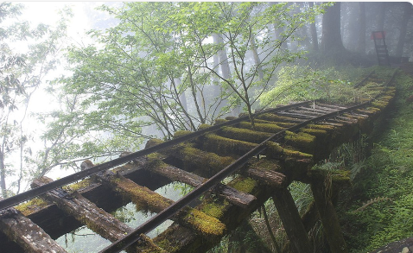

Task 1: Brackets ()

We sometimes use brackets to add additional information that may help the reader to visualise the scene better or to provide additional information.

E.g.1 Mrs Blackwood (the P5/6 Teacher) created a writing lesson for her class.

E.g.2 A young girl (approximately twelve years old) appeared in the distance from behind the tall, stone wall.

Sentence challenge!
Can you place the missing bracket in the sentences below?
A strange shape that seemed to be moving rather quickly) could be seen on the old, rickety track.
The noise (which was deafeningly loud echoed through the woods.
Can you write 2 sentences of your own that contains brackets, try to link them to the picture above?

Adjectives  (describing words) | Prepositions  (words/phrases that describe the position of something e.g. beneath the heavy sky, next to the tall skeleton tree) | Adverbs  (words that describe a verb e.g. slowly, quickly) | Punctuation  (example of sophisticated punctuation that you could use to engage the reader and up level your work)
Task 2: Complete the grid below with words/phrases to help you describe the Old Railroad scene.

Task 3: Story Starter
Using your ideas above, write the starter (you can write the whole story if you would like) for an imaginative story based on the picture above. Your title should be ‘The Old Railroad’.
Please try to include at least one set of brackets to provide additional information.
You can type your story at the bottom of this document, or you can hand write it in your jotter. If you hand write it, perhaps you could scan or screenshot a copy to send to me – ask your parents to email it to the School address.

Here is an example story starter to give you some inspiration…

The Old Railroad
It had been many years since the shrill shriek of a steam train puffing along the track had been heard in these parts.
The Northern Railroad had been discontinued after the great disaster on June 11th, 1911. Ever since that day, the Railroad company had been nothing but a distant memory, a story to be told around the campfire late into the night
As the group sat around their newly constructed camp, listening to the crackle of the flames as they licked up into the night, their minds wandered back to the stories they had heard from their fathers. So absorbed were they in the moment, and the mesmerizing glow of the fire, that it was hard to tell if the shrill shriek coming from the distance was part of their imaginations…

The Old Railroad

