**Skene School Bulletin 2 30.09.16**

**Working Together, Learning Together, To Be The Best We Can Be**



**A message from Miss Hampton…**

It is hard to believe that we are only a week away from the October holidays already – where does the time go?! It has been a busy yet successful start to the school year for us. We continue to work hard to meet the needs of all of our learners and to provide a fun and positive learning environment for all. All staff have worked hard to get to know the pupils in their class and their learning needs and styles with all classes making good progress in all subject areas. We ask that parents continue to work with us to ensure we provide the best support for each individual pupil.

I wish you all an enjoyable and relaxing holiday and hope that you all get a break from work to spend some time with your children. I look forward to all of the stories on our return. On behalf of all of the staff and myself, thank you for all of your support this term.

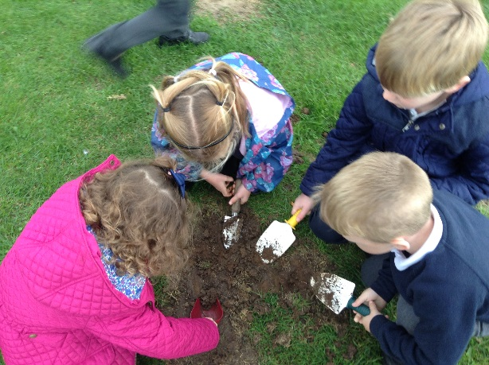**Class News…**

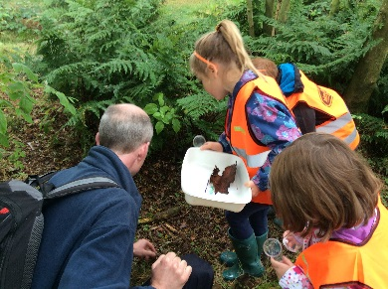**By James:** In P1/2 our topic is Minibeasts and we have been reading James and the Giant Peach along with this. We have made our own peaches out of paper mache and we have made giant characters for the wall. We went on a class trip to Carnie Woods and saw lots of spiders! We also saw worms, millipedes and centipedes. Did you know that Ladybirds can fly?!

In Maths we have been learning and practising our numbers up to 10. In Primary 2 they have been revisiting our number bonds to 20 and continuing to develop our mental maths skills using interactive games and the Big Maths challenge.

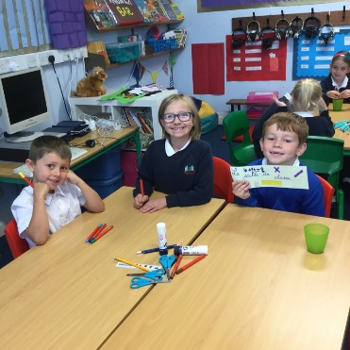In French we have been learning to say Bonjour and Au revoir. We have also been learning different colours and how to count to 10.

**By Mack:** In P2/3/4 we have been learning about Roald Dahl. We are reading Charlie and the Chocolate Factory and are up to Chapter 3. We had great fun organising Roald Dahl Day for the whole school – we were all dressed up as a Roald Dahl character – I was Charlie Buckett with a Golden Ticket.

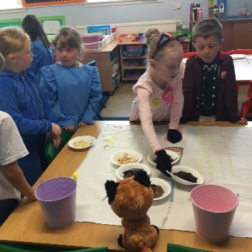Our classroom is quickly turning into scenes from Charlie in the Chocolate Factory. We have Willy Wonka and the Golden Gates, Wonka bars, sweeties and today we have been turning ourselves into Oompa Loompa’s.

In Maths we have been learning about shape and now are we working on Place Value. We are re-visiting number bonds to 20 (P2/3) and 100 (P4).

Next week we are going on a trip to the Aberdeen Science Centre – we are very excited about this!

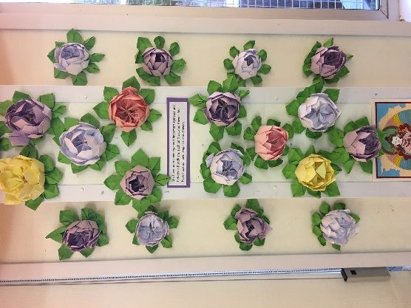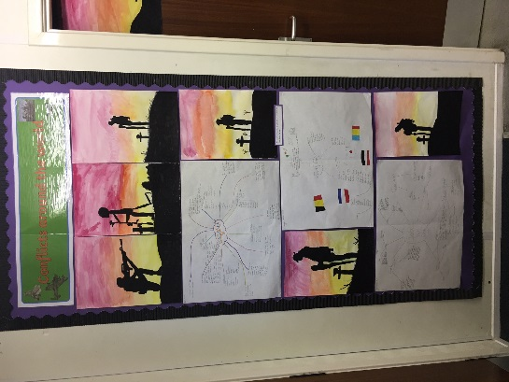**By Jess**: In P5/6/7 we have been learning lots of new things this term. We have been learning symmetry in maths, reflecting the shapes over the lines to make them bigger. Also we have been learning about angles and finding out the degrees of lines and in shapes. In writing we have been focusing on functional pieces such as newspaper reports and reports. We have written about the Falklands War and The Battle of Stirling Bridge.

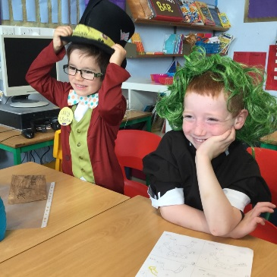Our topic is Conflicts around the world. In topic, we have looked at different wars like the Syrian war, Vietnam War and World War 1. We have been exploring Buddhism in RME, learning all about what they believe. The class looked at meditation, symbols and beliefs. The lotus flower is a symbol and we made lotus flowers out of origami.

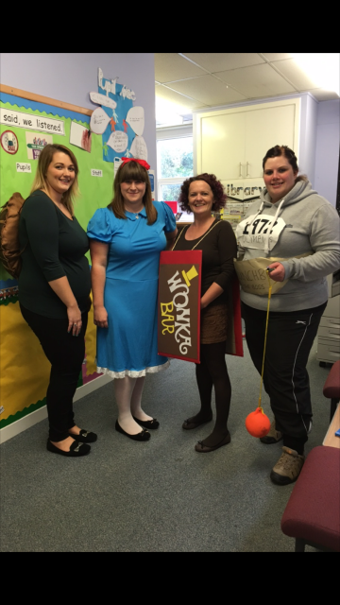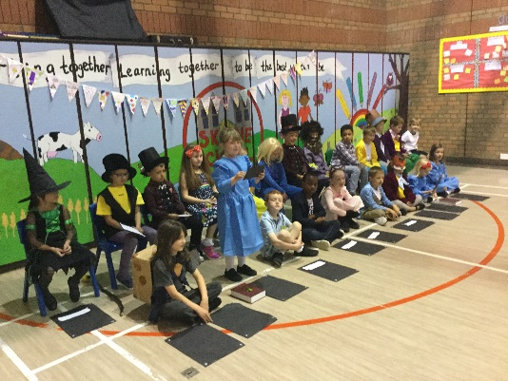**Roald Dahl Day**

On Tuesday 12th September we celebrated Roald Dahl’s 100th birthday. Primary 2/3/4 organised a fun-filled day of learning and excitement for the whole school. We had activities such as chocolate tasting, dressing up, quizzes and a beetle drive. We all had a great day and well done to Miss Law and P2/3/4.

**Inspection Report**

Our HMIE Inspection report was published earlier this term. It can be located at the following address:

<http://www.educationscotland.gov.uk/inspectionandreview/reports/school/?search_school_name=Skene&search_school_coverage=Aberdeenshire&search_inspectionreport_publishedafter=&search_inspectionreport_publishedbefore=&Submit=Search>

Following the inspection we have a clear way forward, knowing our strengths and areas for development.

**Snappy September**

Thank you to all of our young and budding photographers for your entries to the Snappy September Photograph Competition. We have a fantastic array of pictures displayed in the Library area. Well done to Gregor Buckett who won 1st prize, Innes Munro who came 2nd and Owen Reid who came third.

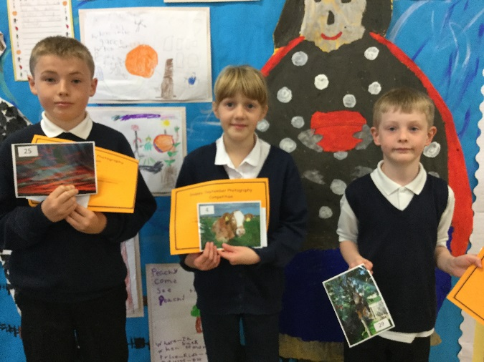All photographs has been sent to Mrs Buckett and we hope to see some of them in the annual calendar for 2017.

We hope to run more competitions like this so watch this space for the next theme…

**Barcaple 2017**

Our Primary 7 pupils are already looking forward to their trip to Barcaple from 5th June to 9th June. 8 of our pupils and a member of staff will join the Primary 7 pupils from Crombie for their residential trip. The children appear to be excited already with many conversations being had and questions being asked.

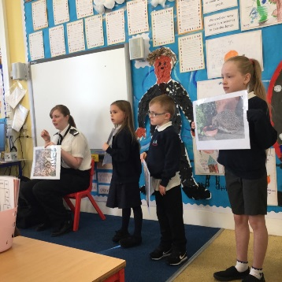**SSPCA Visit**

Monday 26th September we had a visit from the SSPCA. P1-4 enjoyed a short Assembly which was followed by a workshop for our P4-7 pupils. The workshop focused on Animal 999. The children enjoyed the session and we hope to do more work with the SSPCA soon.

**Names on belongings**

We ask that you please name all items of clothing and footwear that belong to your child/children. We already have an increasing pile of unnamed items, especially in Primary 1/2 and no children claiming them. We will put them out at Parents Evening so please have a look and see if you recognise anything. All of the staff would be very grateful of your support with this.

**The Cat Parade – ‘Zen’**

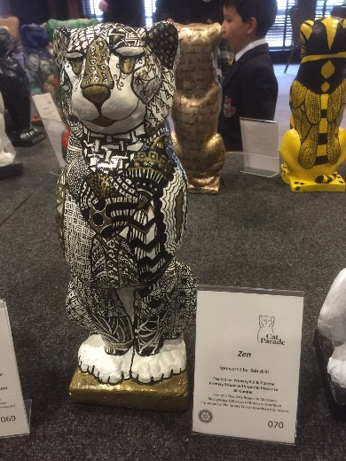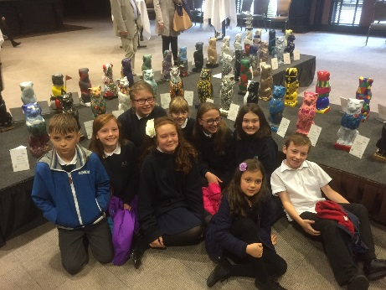Our P5/6/7 pupils and the teachers were very lucky in having the opportunity to help Mrs Cooper, our art teacher, design a Cat for the Cat Parade 2016. The project was organised by Aberdeen’s Bon Accord Rotary Club to commemorate their 100th anniversary. Similar projects include Kelly’s Cats in 2005 and 2014’s Wild Dolphin sculpture Trail.

9 of our pupils were lucky enough to visit a pre-auction event on Wednesday afternoon to view all of the cats and see Zen take pride of place.

Zen, sponsored by Sub Drill, went to auction on Wednesday evening and sold for a whopping £620! Well done to everyone involved and a special thanks to Mrs Cooper for asking us to be involved.

**Parent Council**

The Parent Council held their AGM and first meeting of the year on Tuesday 30th August. Lesley Munro will remain as Chairperson and Lindsay Thomson as Secretary. Lynne Pirie has taken over as Treasurer. It was great to see a few new faces too.

Fundraising this year will continue to support the school in our bid to become a 1-1 school with ipads and to enhance digital literacy skills. They will also help fund new reading books and Christmas gifts and experiences for all pupils. Thank you again for all of your support.

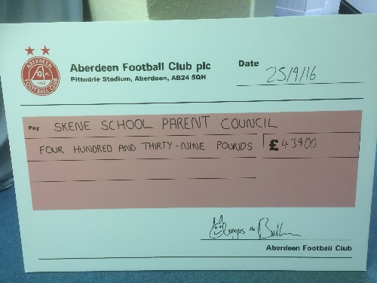Please note the next meeting is on Tuesday 25th October at 6pm**.**

**Dons Day Out**

The Don’s Day out on Sunday 24th September was a great success made even better with a win for Aberdeen. The event raised a fantastic £439.00 to boost the Parent Council’s fundraising efforts. Thank you very much to Mrs Noble for organising this and to everyone who attended.

**After School Care Survey**

Thank you for your responses to the After School Care Survey. Unfortunately the need was deemed insufficient for setting up a service. The main results that justify this decision were as follows:

Question: During term time, how often would you use out of school care?

|  |  |
| --- | --- |
| **After school** |  |
| Everyday | 3 |
| 1 day | 0 |
| 2/3 days | 7 |
| 4 days | 0 |
| Not at all | 4 |
| Occasional | 3 |

To have a club registered with the Care Commission at least two members of staff must be present at each session. To pay their wages and only have 3 or so children is unsustainable.

The team carrying out the survey can provide grants for setting up child minding businesses. If anyone is interested, please let me know and I will pass on the relevant contact details.

**Whole School Panto Visit**

A whole school trip to HMT’s Pantomime, Dick Whittington, has been arranged for the afternoon of Friday 16th December. A letter will be distributed during the first week back advising of timings and requesting that every child has a packed lunch that day – either from home or from the school kitchen. The cost per child will be £10 with the cost of transport and an interval ice cream being funded by the Parent Council**.**

**Road Safety**

As you are all aware, we continue to have safety concerns with the crossing at the Half Miley and the junction to the school car park. This week I have met with local councilor Iris Walker and the Police to help develop a plan to improve safety. I will keep you informed as we progress with this issue. The Police will aim to have more of a presence at the junction as a starting point.

Parents are encouraged to report any dangerous driving to the Police but please consider the reputation of the school when posting on Facebook.

**A few requests:**

* Please ensure that your child has a jacket at school every day. We will be going outside in most weathers, making use of the shelter when necessary. Too many children are coming to school ill prepared.
* Please may I ask that you let us know if there are any changes to normal routines at home which may impact your child at school e.g. parent having to go on unexpected work trip or extended trip etc. Although it can just be for a short time, this can have an impact on your child and it is better that we are informed of this so we can support your child as necessary.
* As we move towards a more eco-friendly school with most communication coming by email, please may I ask that you check your emails regularly. Several parents are contacting the school for information or repeat information before checking emails. If you would like to provide a second email address for your partner etc to ensure communication is received, please let me know and I will add them to the mailing list.
* A reminder that children must remain away from school for 48 hours after being sick. We rely on the honesty of parents to make judgements before sending your child to school if they are unwell/feeling sick. I appreciate this can be inconvenient for work if they have to stay at home however we would like to avoid an outbreak of any sickness bugs.
* Please reply to correspondence by the designated dates. We are having to chase more and more parents for returns which is providing unnecessary workload for the office staff and teachers. If deadlines are not met we cannot guarantee your preferences for events like Parents Evening.
* There is an increasing number of children being taken out of school prior to holiday periods. Although we can only advise that you do not do this, we do ask you to consider the impact on learning and teacher workload – the children have to catch up on return and some lessons have to be repeated.

**Dates for your Diary:**

* Monday 3rd October – P2/3/4 trip to Aberdeen Science Centre
* Tuesday 4th October – P5/6/7 trip to Aberdeen Science Centre
* Tuesday 4th October – Parents Evening 5 – 7pm
* Wednesday 5th October – Parents Evening 3:30 – 5:30pm
* Friday 7th October – Last day of term
* Monday 24th October – Back to School
* Tuesday 25th October – P1-3 Road Safety Magic Show at Dunecht School
* Tuesday 25th October – Rev. Stella Assembly 11am followed by Relax Kids sessions
* Tuesday 25th October – Parent Council Meeting 6pm
* Thursday 27th October – Halloween Disco 6 – 7:30pm
* Friday 28th October – P5/6/7 Curling at The Curl Aberdeen
* Thursday 3rd November – Google Expeditions Trainer in School
* Friday 4th November – P5/6/7 Curling at The Curl Aberdeen
* Wednesday 9th November – Family Bingo Night 6 for 6:30pm
* Monday 14th November – In-service Day
* Tuesday 15th November – In-service Day
* Wednesday 23rd November – Flu Immunisations
* Tuesday 29th November – Rev Stella Assembly 11am
* Thursday 15th December – Christmas Lunch
* Friday 16th December – Whole School Trip to the Panto
* Sunday 18th December – Carols by Candlelight
* Tuesday 20th December – Nativity at Kirkton of Skene Church, 6:30pm start
* Wednesday 21st December – Last Day of Term
* Thursday 5th January – Back to School

**Happy holidays!**

