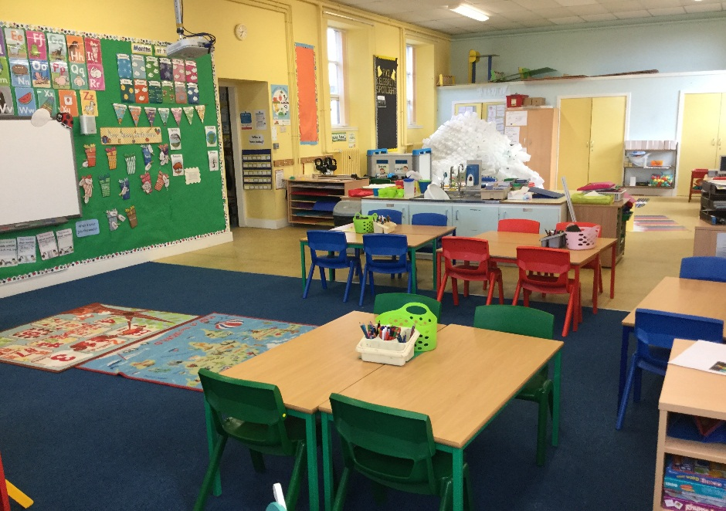

Term 1
P1/2 Skene School
Welcome to P1/2!
A very warm welcome to our new pupils in P1 and 2 and to all of their families too. Welcome back to our P2 pupils and their families! I hope you all enjoyed your Summer holidays and are all set for the busy term ahead. P1/2 have lots to look forward to this term including; a visit from the Countryside Ranger, a trip to the Carnie Woods for a Minibeast hunt, Roald Dahl Day to celebrate his 100th birthday and lots of learning inside and outside the classroom.
I look forward to the year ahead; it is sure to be a busy one!
Miss Bruce
Dates to note:
August:
Monday 29th – P1 begin full days
September:
Thursday 8th – In class visit from the Countryside Ranger
Thursday 15th – Visit to Carnie Woods for Minibeast Hunt
Monday 26th – Visit from SSPCA

Homework
Homework will be given out on a Monday and be due in on a Friday. Homework will consist of Phonics, Spelling, Numeracy, and on occasions Topic. Reading will be sent home twice or three times a week. Please ensure that all homework and reading records are signed.

Community Carousel
All the pupils will be involved in a community group where they take responsibility for a specific area of focus. The groups are mixed so children have an opportunity to work with pupils from different classes. The groups will focus on keeping healthy, rights and responsibilities, Eco and outdoor learning. The groups will meet on a Wednesday afternoon.

Topic
P1/2 will be investigating Minibeasts as our topic this term. We will be taking inspiration from Roald Dahl’s classic novel James and the Giant Peach.
Our topic is Science based as we will be exploring living and non-living things in our local environment. We will be looking at where Minibeasts live and what they need to grow.
We will be making our very own bug hotel to encourage bugs to visit our playground!
We will also be having our very own Ugly Bug Ball!

Timetable
Monday - Library
Wednesday – PE with Mr Strachan
Thursday – PE with Miss Bruce
Friday – Music with Mrs O’Gallaghar

Numeracy
This term P1 will be focusing on number formation using number zoo stories and counting on and back from different numbers.
P2 will begin with some revision of number bonds to 20 and continue to work on mental maths strategies using Big Maths ‘Beat That’ Challenges.
We will also be using the great outdoors for addition and subtraction as much as possible.
Literacy
This term P1 will be introduced to initial phonemes and common words through the Active Literacy scheme. They will learn two new sounds a week with 3 or 4 common words. The children will participate in a range of practical and creative ways to write letters and words.
P2 will be building on their knowledge of phonemes and words and continue to use Active Literacy to begin to use double phonemes or ‘friendly letters’. They will also still have common words to learn each week.

How you can help at home…
To support your child at home, please encourage them to read a variety of texts. It builds up their vocabulary and they are able to see familiar words in different contexts. A great resource to use is called Reading Eggs, it builds up phonetic awareness and supports reading. The children have login details for Education City and Active Learn which are great for consolidating class work.

