Skene School Time Capsule
Below are suggested ideas for each day this week. You can select your favourite for each day, or you can do more than one if you like. It is up to you!
 | Suggestion 1 | Suggestion 2 | Suggestion 3
Monday | Create and decorate your Time Capsule. | Measure how tall you are today. You could use ribbon, thread, wool or paper. (You will need someone to help you). Tie/roll it up nicely and pop a note alongside it to explain what it is. | Draw or take a photograph* of everyone (include your pets if you want) who are living in your house just now.
Tuesday | Using a newspaper or online News site such as Newsround or First News, read and select one story (not linked to Coronavirus) to cut out/print and put in your Capsule. You could always write the Headline and a summary if you would prefer. | Write a note or draw a picture of what you want to be when you are older. Explain why you want to be that.  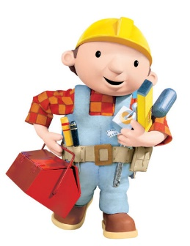 | Go online to www.tesco.com or www.asda.com and find the cost of the following items:  2ltr milk  Loaf of bread  Bag of Plain Flour  An electrical item (your choice e.g. TV, Phone)  Packet of 9 toilet rolls  Add on 3 - 5 items of your choice – it could be your favourite cereal, sweet, fruits, drink etc.
Wednesday | 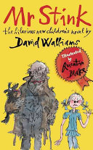  Draw a picture or a version of the front cover from a book you are reading/have read during Lockdown. You could create your own blurb if you like. | Write out a copy of your daily routine during Lockdown. You can choose whether to use the 12-hour clock (8am) or 24-hour clock (08:00).  You could write down what your previous routine was and compare it if you like. | Feelings Graffiti board  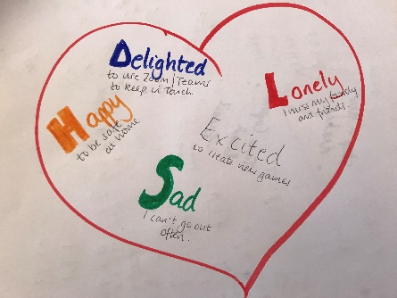  Draw a love heart on a sheet paper and then graffiti how you have been feeling during lockdown.
Thursday | Draw a picture from your bedroom/living room window, alternatively you could do this from your garden.  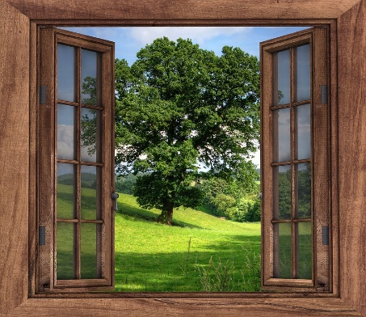 | Draw a picture of a game you have been playing or have adapted during lockdown.  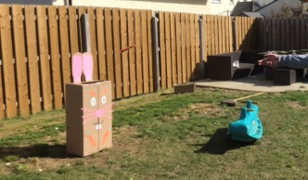  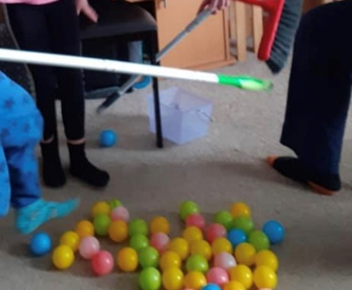  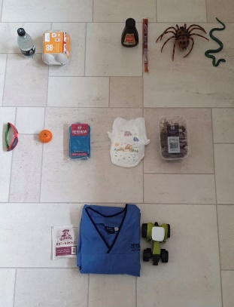 | GEM  Draw a picture of a special gem.  On each section, write the following:  G – anything you have learned that you take for granted  E – note down anything exciting that you have done during Lockdown  M – what/who you are missing during lockdown.  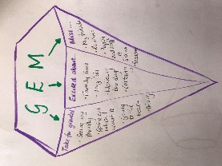
Friday | Write out what your favourite recipe just now. You could also draw a picture or take a photo of it. | Draw around your hands and feet. Cut them out. I wonder how much you will have grown by the time you open your capsule?  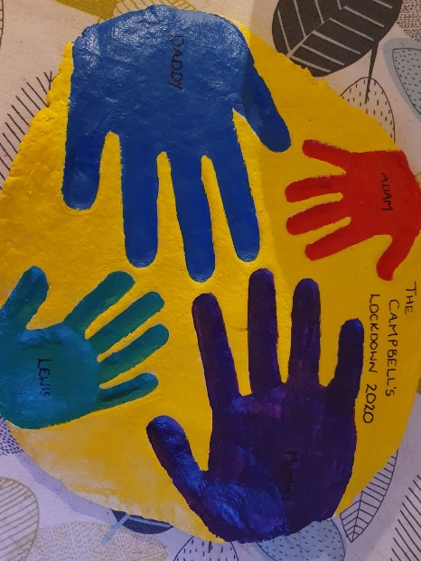  You could create a handprint out of salt dough or even a board with one hand from each family member. | Write down two wishes for the future.

