February p
Learning, Teaching and Assessment Policy – Skene School
June 2023

Contents
Introduction and rationale 3
1 Our Cluster 5
2 Our School 6
3 Our Quality Assurance 7
Appendix 1 Learning Visit and Jotter Sampling 8
Appendix 2 References 12

Introduction and rationale
One of Aberdeenshire Council’s key priorities is “Improving learning teaching and assessment”.

This policy supports all involved in education with the guiding principles to achieve high quality learning, teaching and assessment. It provides what is considered to be best practice to achieve excellence and equity in all of our educational establishments. It also endorses wholeheartedly the educational purposes described in Curriculum for Excellence (CfE). Our starting point is inclusion. Diversity is valued and celebrated.

The curriculum, or “what” we learn is crucial to the success of this policy. We cannot divorce what we learn from how we go about learning it. Skene School has developed a rationale for our curriculum based on the principles of Curriculum for Excellence and the values and needs of those who make up our school community. Many of these values and needs are shared across Aberdeenshire whilst recognising that every local setting is unique.

Curriculum for Excellence (CfE) places learners at the heart of education. At its centre are four fundamental capacities. These capacities reflect and recognise the lifelong nature of education and learning. The four capacities are aimed at helping children and young people to become:
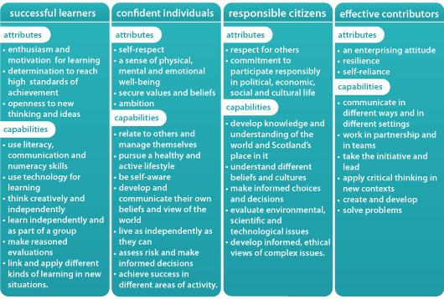
CfE is one of the three supporting pillars of the education system and should be considered alongside Getting it right for every child (GIRFEC, 2006) and Developing the Young Workforce: Scotland’s Youth Employment Strategy (2014). The three pillars of support present as a significant and coherent structure – a pillar for what and how children learn (CfE), a pillar to support children’s well-being (GIRFEC) and a pillar to support children and young people into meaningful work (DYW).
In the next pages, you will see a Westhill Cluster approach to Learning, Teaching and Assessment, outlining shared expectations for the four Primary Schools (Crombie, Elrick, Skene and Westhill). Pages 5 and 6 encourage more depth to what this looks like in our schools and at all levels.

Linked directly to this we have a cluster approach to learning visits with a golden thread through all documentation and linking directly to How Good is Our School (4th edition) and QI 2.3 Learning, Teaching and Assessment.

The learning visit documentation can be found in appendix 1 with all references for this policy in appendix 2.

- Our Cluster 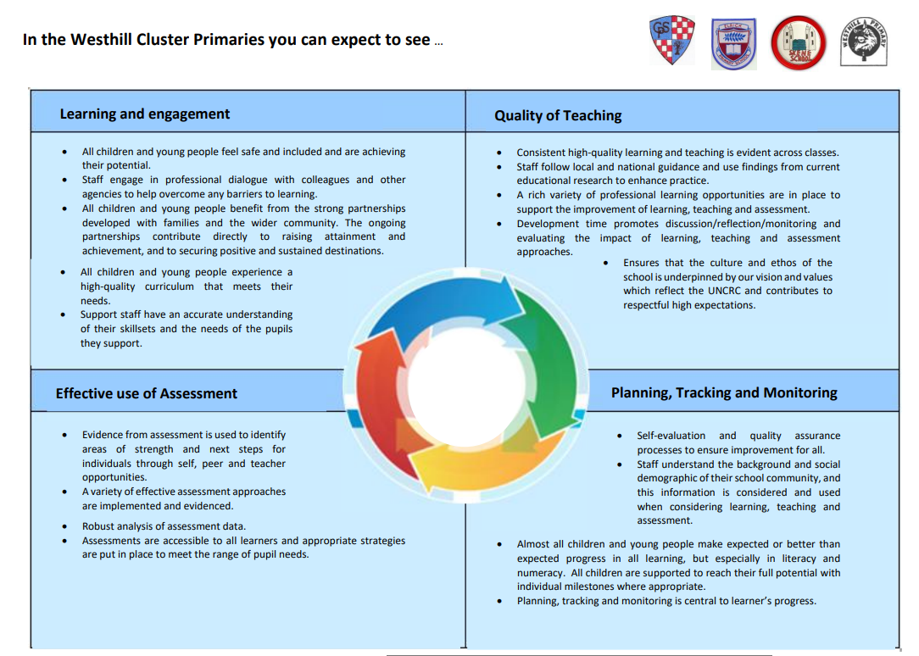
- Our School
In Skene School you can expect to see…
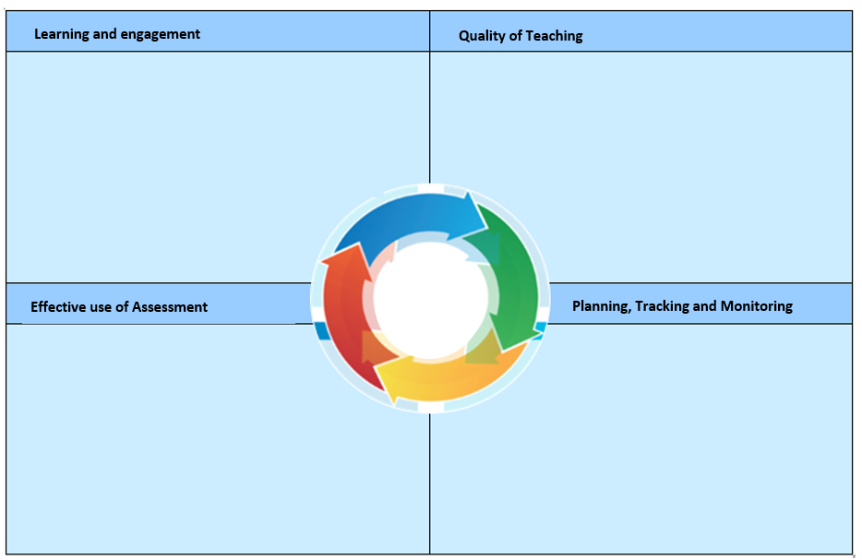
-Robust QA Calendar with clear activities such as moderation, jotter sampling and learning visit proformas.
-Research based practice including Mark Burns, Shirley Clarke and Bruce Robertson.
-Technology integrated into the delivery of learning and teaching.
-Staff make use of different learning environments and a wide range of innovate, creative teaching approaches, to meet needs and interests of all learners.
-Commitment to quality outdoor learning approaches and experiences.
-Nurturing approach.
-Inclusive classrooms.

-Teaching is underpinned by our vision, values and aims.
-Skilled questioning by all staff
-Staff provide high quality feedback.
-Staff use assessment data effectively to plan and secure improved outcomes for each of their learners.

-Learners increasingly responsible for and actively involved in planning and leading learning.
-Learning experiences meet developmental needs of all children.
-Learners are supported by a range of digital technologies and this is embedded in practice.
-Skills based approach to learning.

-Positive relationships between staff and learners.
-Learning experiences underpinned by Vision, Values and Aims
-Ethos of mutual respect.
Learners’ wellbeing is a consistently high priority.
-Multi-agency support as required
-Targeted support via ASL/PSA relating to analysis of TMR discussions.
-Daily Ask me about posts and sharing the learning opportunities
- Challenge groups to extend learning
-Team teaching opportunities and staff sharing skill sets

-Manageable TMR system which is deployed 3 times per year in Nov, Feb and June.
-TMR discussions by class following the above. Whole school overview shared at collegiate sessions.
- Development of new big question approach to IDL.
-Robust QA Calendar in place
-Jotter sampling and monitoring, led by staff.
-HGIOS 4 Challenge questions used to interrogate data.
-Annual cluster attainment review.
Identified areas for improvement are monitored and measured for impact.

-Learning, teaching and assessment are planned in an integrated manner, identifying what is to be learned and assessed from the planning stage.
-National benchmarks are used to improve the validity and reliability of professional judgements of learners’ progress and attainment.
- Moderation processes applied to all aspects of learning, teaching and assessment to improve the validity and reliability of judgements – QA calendar outlines these.
-A quality body of evidence is used to support assessment judgements/decisions.
- 3 TMR meetings per year.

-Planning is proportionate and manageable, clearly identifying what is to be learned and assessed.
- Analysis of data leads to appropriate interventions to address gaps in attainment and achievement, including allocations of ASL and PSA staff.

-Annual engagement in SNSA for P1, 4 and 7.
-Big Writing assessments in Aug, Nov, March and June.
-Teejay diagnostic workbooks
-Nelson Spelling placement test
- AifL strategies including self and peer assessment

- Our Quality Assurance
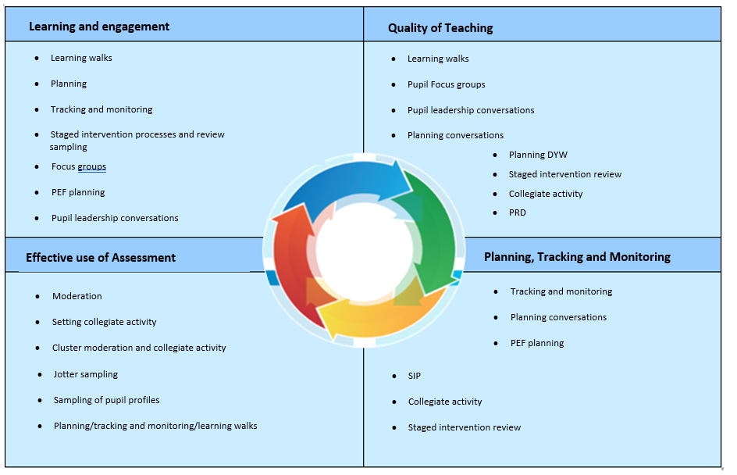

Appendix 1 – Learning Visit Documentation
QI 2.3 Learning, Teaching and Assessment Quality Assurance – Westhill Cluster Learning Visits

Teacher: ____________________________ Class: __________ Date: ___________

This indicator focuses on ensuring high-quality learning experiences for all children and young people. It highlights the importance of highly skilled staff who work with children, young people and others to ensure learning is motivating and meaningful. Effective use of assessment by staff and learners ensures children and young people maximise their successes and achievements. This proforma may be completed from learning visits and follow up discussion with class teacher.

How well are you doing?  What’s working well for your learners? | How do you know?  What evidence do you have of positive impact on learners? | What are you going to do now?  What are your improvement priorities in this area? | How would you evaluate this QI using the HGIOS?4/HGIOELC? Six-point scale?

QI 2.3 Learning, teaching and assessment
Theme 1 Learning and engagement
Is the learning environment built on positive, nurturing and challenging relationships?
Does the learning environment support the sharing and recognition of children’s achievements?
How well matched is learning to the needs and interests of children?

Do teachers fully demonstrate links with previous learning across the curriculum?
Do children realise their achievements help them to develop skills and knowledge for life, learning and work?
Are children engaged in their learning and motivated?
How well is learning appropriately challenging and well matched to children’s needs?

Are they motivated? Are they passive learners?

- What does challenge look like?
- How can we provide challenge for individuals?
- Can learners take risks? Do they?
- Is making mistakes part of the learning?
- Does the task enable learners to explore / investigate?
Are learners asked to explain their ideas, processes or information?
How well matched is learning to the needs and interests of children.

Do staff understand how children in the class learn?
Are children working at a brisk pace? Is it challenging, are they having to think about things?

Notes/Comments:

QI 2.3 Learning, teaching and assessment
Theme 2 Quality of Teaching
How effective are the use of learning intentions and success criteria? (High quality?)
Do learners refer to them? Do teachers link back to them during lessons? How consistent is this across the school?
How effective and consistent are explanations?
Are there high expectations?
Are skills being taught mentioned and / or understood by learners?
How good is the quality of teaching? Is it consistent?
Observation of Teaching
How much time is spent actively teaching?
How much learning is delivered personally to individuals?
Do teachers tackle difficult concepts in small steps, elaborate, enhance and exemplify
How well is learning enriched by digital technology?
Are lessons differentiated and sufficiently challenging? Appropriate pace?
How effective is questioning and the use of higher order thinking skills in extending learning?

- How do explanations make new learning meaningful to children?
- Do teachers present material actively in a structured way?
- Are answers listened to actively and used to enhance learning?
- How often are appropriate open questions asked?
- Are children giving considered answers from their point of view?
- Do children get time to think and reflect before responding? Is this an expectation?

Do children’s answers lead to further questioning and dialogue which follow coherent lines of enquiry?
Are plenary sessions effective?
Do teachers leave sufficient time for children to make sense of their learning?
Do staff give pupils time to think about what they have learned?

Notes/Comments:

Q.I 2.3 Learning, teaching and assessment
Theme 3 Effective use of assessment
How well have expectations and standards in achieving a level been shared / understood?
Are formative assessment strategies being used?
How well are staff using assessment to plan for the needs of individuals?
Is assessment integral to learning and teaching and is it planned?
How reliable and valid is evidence from assessments?
How well is assessment recorded, analysed and used to support learners to attain and achieve?
How well are benchmarks used for assessment?

Notes/Comments:

Q.I 2.3 Learning, teaching and assessment
Theme 4 Planning, tracking and monitoring
To what extent are learners involved in planning learning?
- Do you children know what they are learning and why?
- Are children involved in planning their next steps?

Notes/Comments:

Teacher Comments:

SLT Signature ________________________ Teacher signature _____________________

QI 2.3 Learning, Teaching and Assessment Quality Assurance – Westhill Cluster Jotter sampling

Teacher: ____________________________ Class: __________ Date: ___________

This indicator focuses on ensuring high-quality learning experiences for all children and young people. It highlights the importance of highly skilled staff who work with children, young people and others to ensure learning is motivating and meaningful. Effective use of assessment by staff and learners ensures children and young people maximise their successes and achievements. This proforma may be completed from learning visits and follow up discussion with class teacher.

QI 2.3 Learning, teaching and assessment
Theme 2 Quality of Teaching
Are there high expectations?
Is feedback used to identify success, inform and support next steps in learning?

- How do you use feedback effectively to inform and support progress in learning?
- Is there a consistent language of learning used for feedback?

Q.I 2.3 Learning, teaching and assessment
Theme 3 Effective use of assessment
How reliable and valid is evidence from assessments?

Are children involved in self-assessment/peer-assessment?

Notes/Comments:

Appendix 2

Please see below links to documentation referenced within this policy and others which supported the development of it.

How Good is Our School 4
How Good Is Our Early Years and Childcare
National Improvement Framework
Curriculum for Excellence
Building the Curriculum 3: A framework for learning and teaching
Building the Curriculum 5: A framework for assessment

