 EDUCATION & CHILDREN’S SERVICES

Skene School
Positive Relationships Policy

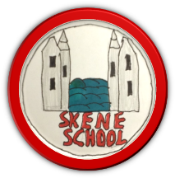
February 2024

The wee school with the BIG heart.
At Skene School we are nurturing and inclusive. We believe every pupil that everybody is somebody (Value E) and is worthy of our time, energy and patience. We aim to make positive behavior the responsibility of all and to equip all our pupils with the skills and understanding to successfully develop and maintain positive, healthy relationships. We expect a high standard of behaviour and understanding of wellbeing underpinned by the UN Convention of the ‘Rights of the Child’. This along with our school’s Vision, Values and Aims promotes a shared commitment to respect for all in our school and wider community. Using a common language, we wish to ensure everyone can fully engage with our vision follow our values and ultimately be fully inclusive in our approach. Through the use of restorative practices, as well as reflection and mediation, we aim to resolve any issues quickly and positively.

Aims

- To create a positive, caring, calm and productive atmosphere in which all pupils are listened to and feel secure in their ability to discuss sensitive aspects of their lives.
- To promote positive relationships and behaviour in the classroom, playground and the wider school community.
- To respect the rights of all learners as outlined in the UNCRC.
- To have clear processes to relationship management in place.
- To provide a safe and nurturing environment where learning to build positive relationships is part of our curriculum.
- To work in partnership with parents and pupils to prevent bullying and maintain high standards of behaviour which promote the well-being of all pupils.
- To be consistent and fair in our approach to managing behaviour.
- To encourage pupils to recognise that they have the responsibility for their behaviour.
- To teach children about their emotions.
- To provide appropriate support by being sensitive and responsive to the wellbeing of each child.
- To model positive interactions.
- Differentiate according to need.
- To have compassion for those who have muddles, are hurting or grieving for whatever reason.

Context of Policy

This policy is in line with Aberdeenshire Relationships, Learning and Behaviour Guidance, March 2022 and the reviewed and revised General Teaching Council for Scotland Professional Standards https://www.gtcs.org.uk/

A whole school nurturing approach and following restorative practices are at the heart of our Relationship Policy. A nurturing approach and being trauma-informed is a focus on wellbeing and relationships and a drive to support the growth and development of children and young people. From research we know that over- compensatory, rich, relational interventions can bring about recovery so that children and young people can function well at home, school and out in their communities. Following these approaches supports pupil engagement and has a positive impact on attainment, social and emotional competences, and confidence.

A Nurturing Approach

At the heart of our approach to positive relationships is our whole school approach to nurture. As a nurturing school, we recognise that positive relationships across the school are central to learning and wellbeing. We recognise that everyone in our community has a role to play and that relationships should be consistent, reliable and predictable where possible. Our nurturing approach allows us to demonstrate a warm, attuned and connected approach to resolving conflict and supporting repair with a focus on achievement and attainment. It is based on the understanding of 6 Nurturing Principles, which have been adapted and outlined below:

- Children’s learning is understood developmentally.
- The environment offers a safe base.
- Nurture is important for the development of self-esteem.
- Language is understood as a vital means of communication.
- All behaviour is communication.
- Transitions are significant in the lives of children.

Our School Vision, Values and Aims

Our recently reviewed Vision, values and Aims reflect our current school community and offers an inspirational narrative to promoting a happy and safe school where everyone is valued and heard.
See appendix 1.

Rights and Responsibilities

In Skene School, we are a UNICEF Rights Respecting School (https://www.unicef.org.uk/rights-respecting-schools/), where children’s rights are unconditional and at the heart of the school. The aim is to work, supported by UNICEF, to create a safe and inspiring place to learn, where children are respected, their talents are nurtured, and they are able to thrive. Our Rights Respecting journey embeds these values in daily school life and gives children the best chance to lead happy, healthy lives and to be responsible, active citizens, using the UN Convention on the Rights of the Child (UNCRC) (https://www.unicef.org.uk/what-we-do/un-convention-child-rights/) as our guide.

At Skene we are focused on promoting equality, reducing bullying and improving the educational experiences of LGBT children and young people. https://lgbteducation.scot/ . We seek to provide information on homophobic, biphobic and transphobic bullying or gender-based bullying as guided by A National Approach to Anti-Bullying for Scotland's Children and Young People with staff and pupils engaging with http://www.lgbtyouth.org.uk/ to ensure inclusion for all. Our policy has been created in line with the Equalities Act (2010) and respond to the needs of all relevant protected characteristics, including sexual orientation and gender-reassignment. Central to our approach is the recognition that every member of the school community has rights as well as being required to respect the rights of others; taking responsibility for actions and ensuring that the rights of others are unconditional and not encroached upon.

All of our stakeholders have rights as below

Rights of Pupils:
- To be able to enjoy their learning.
- To be treated with respect.
- To be listened to.
- To feel safe.

How to respect the rights of others – Pupils:
- To behave in a way which allows others to learn.
- To treat others with respect.
- To listen to others.
- To allow others to feel safe.
- To strive to meet our school values
- Follow our class and playground charters.

Rights of Staff
- To enjoy the teaching and learning environment in which they work.
- To be treated with respect.
- To be listened to.
- To feel safe.

How to respect the rights of others – Staff:
- To be aware of relevant documentation, including policies, and the range of strategies, and sources of advice, but also of the many factors which influence behaviour which are outwith our control.
- To believe in and follow our School Vision, values and aims.
- To treat pupils fairly, with respect and due confidentiality.
- To promote and maintain a safe and stimulating environment for everyone.
- To aim to meet all pupils’ needs e.g., ASN, trauma, ACEs.
- To apply this policy fairly and consistently.
- To keep parents and carers informed of their child’s educational, personal and social development, including issues related to behaviour.

Rights of Parents and Carers
- To know that their children are safe and happy.
- To participate in positive communication with the school.
- To be treated with respect.
- To be listened to.

How to respect the rights of others – Parents and Carers
- To take an active role in their children’s education.
- To support the school staff in encouraging positive behaviour.
- To treat all staff and pupils in the school with respect and pay due regard to confidentiality.
- To inform appropriate school staff if they have any concerns relating to behaviour in the school; contact will be made either in writing (via homework record, communication book or letter), by telephone, or at an organised meeting.

Encouraging Positive Behaviour and Achievement

Pupils and Staff follow our School Values which are displayed in each classroom and around the school. At the start of every academic session a class charter will be created with the pupils and will be referred to throughout the year.

At Skene School we use a variety of ways, as appropriate to the situation and individuals, to promote and recognise positive behaviour and achievement. These may include:

- Education through our Health and Wellbeing curriculum. This also includes inputs from other professionals; e.g. Police Officer.
- Positive impartial and open body language and tone of voice.
- Celebration of wider achievements
- Celebration of success
- School Values stickers.
- Recognition of Achievement at Assemblies e.g. showing of learning, demonstration of skills, presentation of certificates, etc.
- Sharing the learning opportunities through Open Mornings, Parents Evening and Just2Easy.
- House System and associated points.

Supporting Positive Relationships

At Skene School we use a variety of methods to support the pupils to make the right choices available to them depending on their needs and situation. These include:

- Intervention Prevention Teacher
- Nature Nurture Practitioner
- School Counsellor
- In house nurture teacher
- Informal discussions with parents and carers
- The Staged Intervention process
- Play
- Visual timetables
- Autism friendly classroom
- Robust Health and wellbeing program
- Relationship Sexual Health and Parenthood Programme (RSHP)
- The Resilience Programme
- Dyslexia friendly school
- GIRFEC Aberdeenshire principles and documentation.
- Family Nurture Leaflets | (glowscotland.org.uk)

Global strategies used include:
- Use of emotional check ins.
- Whole school, rights respecting, aligned restorative conversations implemented by pupil support assistants, class teachers and HT, script (appendix 2)
- Assertive redirection statements (appendix 2)
- Restorative conversations log to record incidents (appendix 3)

Restorative Approaches

Restorative Approaches provides an underpinning ethos and philosophy for making, maintaining and repairing relationships and for fostering a sense of social responsibility and shared accountability.
Restorative approaches:
- Build and repair relationships
- Develop and maintain mutual respect
- Preserve a sense of belonging, strengthen community ties
- Ensure that everyone is given a voice and feels heard
- Empower those with conflict to resolve it for themselves
- Ensure accountability
- Develop empathy and conscience.

The aim is for the person who shows unacceptable behaviour to recognise it, acknowledge responsibility, apologise to those harmed and to make amends. Restorative questioning has a specific sequence for the person who has been wronged and for the person who has shown unacceptable behaviour.

What if there is challenging behaviour?

When a child is displaying challenging behaviour either verbally or physically towards another child or member of staff, we understand that the steps previously described may not be appropriate.

In these circumstances staff should aim to de escalate the behaviour using a variety of agreed methods, sensitively taking into account the needs of the pupil and the situation. The teacher/PSA should send for help from another adult/the Head Teacher who will respond. The class should be removed to a safe location in the school if they are at risk of harm and a member of staff should remain with the child in crisis. A member of staff must remain and support pupils until another member of staff/the HT is available to assist.

The parents of the pupil in crisis will be informed of the incident and will be invited to a solution focused meeting to discuss next steps. The parents of any pupil harmed, if applicable, will be contacted.

Educational Psychology and a multi-agency support system should be activated.

For pupils who require support beyond the classroom, school staff will:

- Support the pupil’s needs to the best of their ability in class.
- Initiate the CIRCLE approach including participant scale.
- Provide an adapted or supported curriculum to meet the needs of the pupil.
- Discuss effective strategies and engage in a solution focused meeting to ensure the pupil gets the right support at the right time.
- Ensure the classroom is providing a nurturing environment.
- Communicate effectively with parents/carers.
- Involve external agencies where appropriate and as required.
- A risk assessment will be in place.
- Engage in the Child’s Planning process to ensure the correct support at the correct time.

Playground

Our school vision, values and aims, and the school charter apply in the playground. Pupil Support Assistants (PSAs) and sometimes other staff members (HT) supervise the playground during breaks. PSAs are equipped to engage in restorative conversations to resolve playground incidents and concerns. Their remit includes encouraging and supervising games, both indoor and outdoor, helping to resolve minor disputes, and ensuring, as far as possible, the safety of pupils in their play. They will record incidents and inform the class teacher or promoted staff who will take action as appropriate.

Consequences

Taking responsibility and being accountable for the pupil’s actions and behaviour and how they may not have respected the rights of others may involve the following consequences:

Consequences include: - missing play time
- discussion with member of staff/HT
- letter of apology
- Temporary exclusion.

Temporary Exclusion from School

At Skene School, this is considered a last resort. There may be a need to refer to Aberdeenshire’s promoting Inclusion and Reducing Exclusions Policy and follow the necessary procedures and processes.
Following the publication of Included Engaged Involved Part 2: A Positive Approach to Preventing and Managing School Exclusions, guidance published by The Scottish Government in June 2017, Education and Children’s Services identified this as an opportunity to revise and update policy and practice in relation to exclusion, recognising that current exclusion policy predates some national guidance and legislation.
The revised policy states:
Regulation 4 provides that an education authority shall not exclude a pupil from school unless the authority:

- "are of the opinion that the parent of the child or young person refuses or fails to comply, or to allow the child or young person to comply, with the rules, regulations or disciplinary requirements of the school";

or

- "consider that, in all the circumstances, to allow the pupil to continue his/her attendance at the school would be likely to be seriously detrimental to the order and discipline in the school or the educational well-being of the pupils there."

Bullying

At Skene School we follow Aberdeenshire Council’s Anti Bullying Policy.

In accordance with Scotland’s National Anti-Bullying Service; ‘Respectme’, Aberdeenshire Council Education and Children’s Services define bullying as the following: ‘Bullying is both behaviour and impact; the impact is on a persons capacity to feel in control of themselves. This is what we term as their sense of ‘agency’. Bullying takes place in the context of relationships; it is behaviour that can make people feel hurt, threatened, frightened and left out. This behaviour happens face to face and online.’ Respect for All: The National Approach to Anti-Bullying for Scotland’s Children and Young People 2017
.
With the above statement in mind, we will not use the labels ‘bully’ but will treat bullying as an inappropriate behaviour which will not be tolerated, has to be dealt with (in an appropriate manner, as discussed in this paper) whilst also investigating the complex social dynamics to ensure that the situation does not continue.

The Equality Act 2010 supports progress on equality and particularly in relation to the protected characteristics.

Bullying is both behaviour and impact; the impact is on a person’s capacity to feel in control of themselves. This is what we term as their sense of ‘agency’. Bullying takes place in the context of relationships; it is behaviour that can make people feel hurt, threatened, frightened and left out. This behaviour happens face to face and online. (Respectme 2015)

At Skene School, we:
- Believe bullying is a breach of the UN convention of the Rights of the Child.
- Have an explicit commitment to challenge all types of prejudice-based bullying.
- Have a commitment to training staff and volunteers through Respectme.org.uk
- We engage with HGIOS 4 QI 2.4 and 3.1 through self-evaluation and reflection.
- Take solution orientated approaches.
- Provide mentoring and peer support.
- Provide inclusive and supportive learning environments.

Skene staff will record any incidents of bullying or prejudice-based discrimination reported to them using the Bullying & Equalities module of Seemis.

Incidents which will be documented will include ones of a serious or ongoing nature, as well as incidents where a member of staff, pupil or parent would like it documented.

By recording such incidences, we will:
- ensure that there has been an appropriate and effective response.
- identify recurring patterns including:
- identify whether a particular problem is ongoing and whether further professional development may be beneficial to staff.

Aggressive or violent behaviour, by pupil or adult, will be reported on the Aberdeenshire Violent Incident Report Form. Racial incidents will be recorded on Aberdeenshire Council’s Bullying and Equalities module.

Evaluation of Policy

This policy should be reviewed every 3 years with children, staff and parents.

References:

Know me to Teach Me – Louise Michelle Bomber
After the Adult Change – Paul Dix

Aberdeenshire’s anti bullying policy

Aberdeenshire’s Promoting Inclusion and Reducing Exclusions Policy

Aberdeenshire’s Relationships, learning and behaviour Guidance

UNCRC Rights of the Child

Educational Psychology Department- family nurture.

Included, engaged and involved part 2: preventing and managing school exclusions

https://www.gov.scot/news/milestone-for-equality-in-schools/

Respect for all - https://www.gov.scot/publications/respect-national-approach-anti-bullying-scotlands-children-young-people/

Appendix 1 – Skene School Vision, Values and Aims

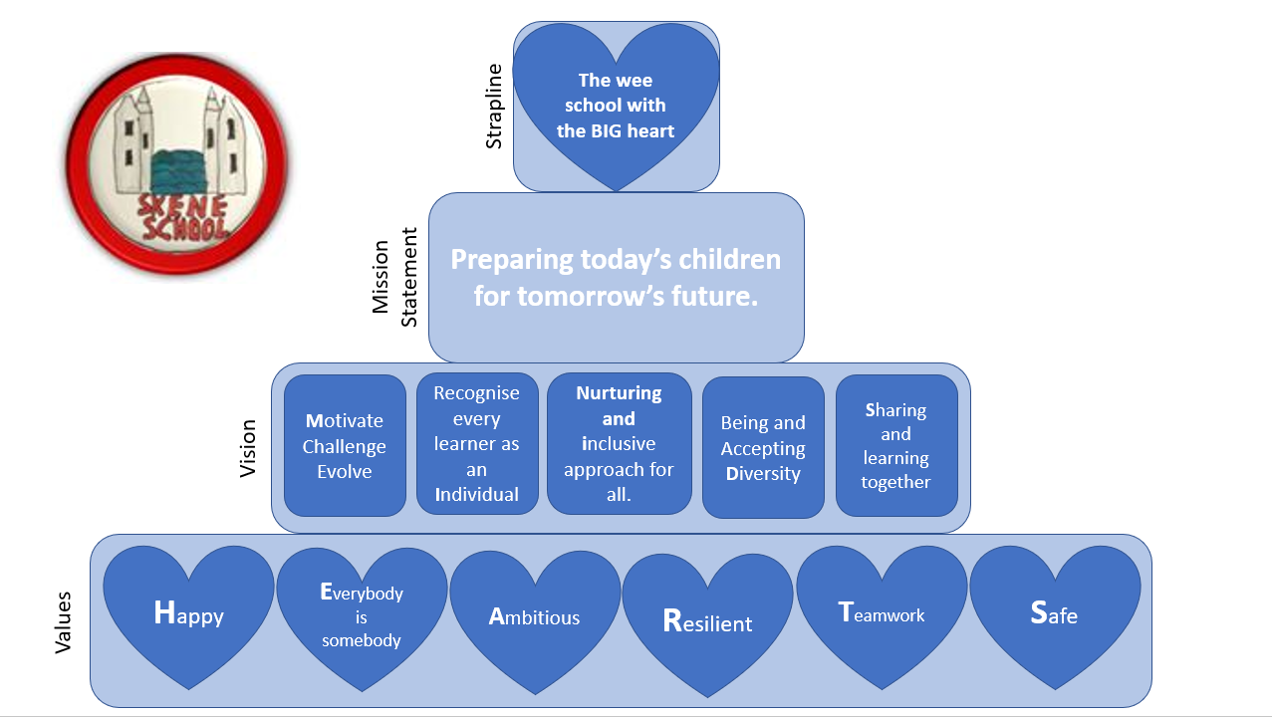

Appendix 2

Restorative conversation scripts and assertive redirection statements

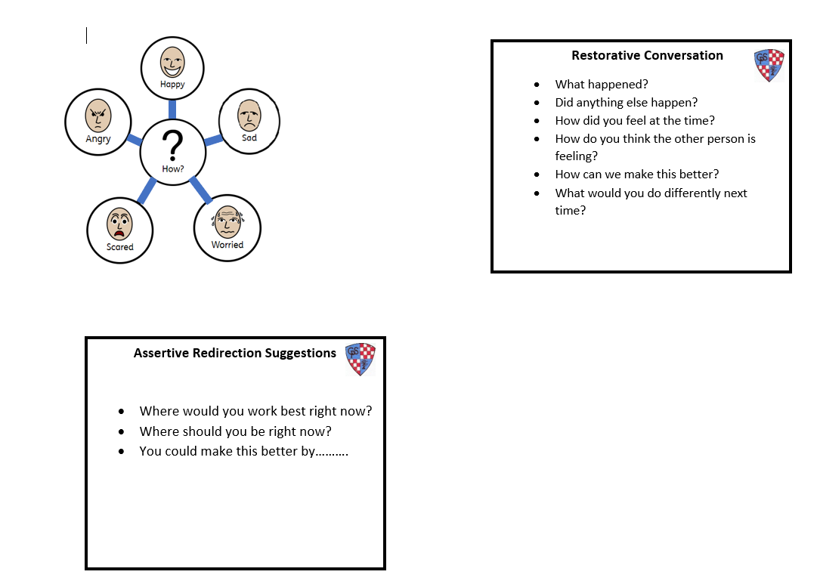

Appendix 3 - Restorative conversation log

Date | Child1 initials/Class  Victim | Child 2 initials/Class  Perpetrator | Other children | Comments (if appropriate) | Dealt with by  (print name) | Passed to (if necessary)
EXAMPLE | VV P1 | PP P3 | None |  | Mrs PSA | CT/HT
 |  |  |  |  |  | CT/HT
 |  |  |  |  |  | CT/HT
 |  |  |  |  |  | CT/HT
 |  |  |  |  |  | CT/HT
 |  |  |  |  |  | CT/HT
 |  |  |  |  |  | CT/HT
 |  |  |  |  |  | CT/HT

