Rep
Education and Children’s Services
Health & Safety for Education:

Fire Safety Strategy and Arrangements
Skene School
Updated 08.01.24

Contents
1 Fire Safety Strategy Statement 3
2 Responsibility for Fire Safety 4
2.1 Head Teacher (Primary & Special Schools) 4
2.2 Head Teacher (Secondary Schools) 5
2.3 School Leadership Team 5
2.4 Cluster Business Manager 5
2.5 Principal Teachers, Faculty Heads and Managers / Supervisors 6
2.6 All Employees (All Schools) 6
2.7 Pupils 7
2.8 PPP Schools 7
3 Fire Safety Arrangements 7
3.1 Fire Sategy Arrangement Checklist 7
3.2 Emergency Response Procedures 8
3.3 Information and Training 8
3.4 Fire Fighting 9
3.5 Fire Fighting Equipment 10
3.6 Testing and Maintenance 10
3.7 Recording Information and Record Keeping 11
3.8 Audit and Review 11

Fire Safety Strategy Statement
Skene School is committed to giving fire safety high priority, in order to meet our legal duties as set out in the Fire (Scotland) Act (2005) and Fire (Scotland) Regulations (2006) as well as our moral and ethical responsibilities to staff, pupils and others who may be affected by our work. Whilst managing the risk of fire helps protect property, the objective of this strategy is to protect life.
We expect staff, pupils and other building users, visitors and contractors to share this commitment by complying with our policies, strategies, procedures and guidelines and to understand that they have individual legal and moral responsibilities to protect their own safety in respect of harm caused by fire and that of all other people affected by their acts or omissions.
Skene School is committed to managing fire safety by:
- Providing, managing and maintaining workplaces and work environments which are, so far as is reasonably practicable, safe in respect of harm caused by fire;
- Implementing systems of work that are safe in respect of harm caused by fire;
- Managing and maintaining premises, plant and equipment so that they are, so far as is reasonably practicable, safe and that risks from fire are controlled;
- Providing information, instruction, training and supervision as necessary to ensure that the likelihood of fire is reduced and the impact in case of fire is as small as possible;
- Providing the necessary organisation, expertise and resource, including communication, consultation, planning, monitoring, inspection and auditing to ensure that there is effective management of fire safety; and
- Keeping up to date with best practice in relation to fire safety, complying with all relevant legislation and authoritative guidance.

We undertake to review and develop our fire safety management systems and to review this strategy at least annually and as required whenever there are changes to the scale and nature of our activities.

Amanda Blackwood
Head Teacher
08/01/2024

Responsibility for Fire Safety

Head Teacher (Primary and Special School)
Overall accountability for fire safety lies with the Chief Executive of Aberdeenshire Council, with responsibility for fire safety for this site delegated to the Head Teacher, as the Duty Holder who has responsibility for: -
- developing, keeping under review and authorising the School Fire Safety Strategy and for ensuring its effective implementation throughout the school;
- overseeing the school’s arrangements for the management of fire safety and for reviewing the school’s fire safety performance;
- ensuring the implementation of Skene School’s Fire Safety Strategy, associated arrangements, e.g. Emergency Evacuation Plan, and that enough people are identified and trained to carry out the sweep of the section of the building allocated using the Fire Check Lists;
- consulting and engaging with colleagues both through formal (union) and informal mechanisms;
- taking steps to ensure that management responsibility for fire safety is clearly allocated at all levels;
- ensuring that adequate resources are allocated for the school to meet its fire safety responsibilities;
- ensure the securing of relevant competent fire safety advice which is appropriate to the nature of the school’s activities;
- organising specialist advice as required from Aberdeenshire Council Health and Safety Team;
- ensure the delivering induction training, including fire safety, to new staff members; trainee teachers; and to non-Aberdeenshire Employees who work in the building;
- liaising with [PPP colleagues and] other service providers working on site on fire safety matters and liaising with facilities colleagues regarding Fire Risk Assessment;
- co-ordinating any remedial actions identified through Risk Assessment or Audit in co-operation with other services, partners.
- ensuring that arrangements for pupils leaving class during lessons are thoroughly adhered to, and to reduce the opportunity for wilful fire raising;
- identifying timings for and arranging fire evacuation drills as required each term; and
- ensuring that fire hazards are suitably controlled.
- ensuring the completion of PEEPs as appropriate, and sharing of this information with relevant staff members and available should an evacuation be necessary.

In addition, a session on fire safety and fire evacuation is run at the beginning of each academic year, and that new pupils have a dry run of leaving the building and mustering in the correct place at the fire muster location.

School Leadership Team
The School Leadership Team has overall responsibility for: -
- ensuring that those under their line management take all necessary actions to satisfy the requirements of the Fire Safety Strategy.

All Employees
All employees have a duty to take all reasonable steps to preserve and protect their own safety in respect of harm caused by fire and that of all other people affected by their acts or omissions. Staff should familiarise themselves with this strategy, the action plan and escape routes. Staff should be able to activate the alarm and understand the school procedures in the event of an emergency. They are further responsible for co-operating and complying with the requirements of the Fire Safety Strategy and working in accordance with its associated procedures including: -
- adhering to all risk control measures;
- taking action to rectify or report all fire hazards;
- drawing to the attention of the organisation anything they believe to be deficient in the organisation’s fire safety arrangements; and
- have an awareness of fire extinguishing equipment and how to use it in the event it is needed in order to evacuate a space in the event of an emergency.

In addition, registration teachers are responsible for ensuring that their group is familiar with the Fire Evacuation Procedures and that P1/S1 registration groups leave the building and muster at the appropriate muster location during the first two weeks of the new school year.

Pupils
Pupils are responsible for: -
- engaging with and complying with information relating to their safety in relation to fire, including how to evacuate the building;
- following instructions when their learning includes the use of sources of ignition;
- ensuring their actions or omissions do not result in fire; and
- ensuring they do not recklessly or intentionally interfere with, or misuse, anything on the school site.

In addition, registration teachers are responsible for ensuring that their group is familiar with the Fire Evacuation Procedures and that P1/S1 registration groups leave the building and muster at the appropriate muster location during the first two weeks of the new school year.
In addition, a session on fire safety and fire evacuation is run at the beginning of each academic year, and that S1 pupils have a dry run of leaving the building and mustering in the correct place at the fire muster location.

Fire Safety Arrangements Check List

Please update the table below with information pertinent to your establishment. Please complete to confirm arrangements are in place and advise the location of relevant documents before sharing will all members of staff for the site. This information will be need to be passed to the Chief Fire Officer of Fire Scotland if they attend the site:
Fire Safety Arrangement Check List | Add Site Details In this Column: | Comments: | Date:
Duty Holder (Head Teacher) Name: | Amanda Blackwood | Head Teacher | 08/01/2024
Individuals appointed as fire wardens in the event of a fire situation: | Neil Walker – Janitor  Julia Minshull – Administrator  Alison Powell – Admin Assistant | All part time staff therefore several named members to ensure cover. | 08/01/2024
Staff member with specific role of checking information displayed on fire panel when fire alarm sounds within and outwith school term/day assigned and trained to undertake task: | Neil Walker – Janitor  Julia Minshull – Administrator  Alison Powell – Admin Assistant | All part time staff therefore several named members to ensure cover. | 08/01/2024
Staff members with specific role of investigating the area identified on the fire panel as triggering the fire alarm within and outwith school term/day assigned and trained to undertake task: | Amanda Blackwood  Neil Walker – Janitor (if in school at time) | Head Teacher/Janitor | 08/01/2024
Staff members with specific role of calling the fire and rescue service on 999 if on investigation a fire is suspected or found within and outwith school term/day assigned and trained to undertake task: | Any member of staff who upon investigating a concern or notification from the fire panel suspect or confirms a fire
Staff with specific roles during an emergency evacuation procedure are: | Amanda/Neil – checking area for fire  Julia/Alison/Neil – reading fire panel  Amanda ensuring everyone is accounted for, providing information to fire service on arrival.  Michelle/Jessica/Debbie/Kirsteen – supervision of pupils  Alison/Lynne/Lorraine – register of visitors |  | 08/01/2024
The person designated to provide information to the fire service on arrival is: | Amanda Blackwood | Head Teacher | 08/01/2024
List here arrangements for searching areas of responsibility when evacuation the building to ensure all pupils and staff are clear of the building: | Amanda – Library, staff room, offices and staff toilet  Julia/Alison – Office, pupil toilets (office corridor), gym hall  Lorraine/Kelly – kitchen, kitchen office and toilet  Kirsteen – Room 2, pupil toilets and disabled toilet in main corridor  Jessica/Debbie – cloakroom/Rooms 1A+B  Michelle – Port-a-cabin and toilets within | Some job share arrangements here hence more than one name stated. | 08/01/2024
Name of colleague the ‘all clear’ of designated search area is stated to on evacuation: | Amanda Blackwood | Head Teacher | 08/01/2024
Fire Risk Assessment file is available and located at: | Skene School Reception |  | 08/01/2024
FRA Fire Safety checklist is located at: | Skene School Reception |  | 08/01/2024
Emergency evacuation procedure file is available, reviewed at regular intervals and located at: | Skene School Reception  (also copy in Grab bag) |  | 08/01/2024
Building map layout located at the Fire Panel and notes high risk areas (chemical storage, fire alarm zones, shut off points for services, etc) for the attending fire service: | Yes | Map available for visitors next to sign in book/badges | 08/01/2024
Fire drills are carried out termly and details recorded can be located with the Fire Safety Inspection & Maintenance Logbook located: | Yes.  Located in Skene School Reception | Records maintained by Neil Walker, Janitor | 08/01/2024
Fire safety training is delivered at induction and each August In-Service day by: | Amanda Blackwood | Head Teacher | 08/01/2024
The assembly point is situated at: | Top left hand corner of pitch |  | 08/01/2024
Specific details of mustering arrangements for registration groups, staff, visitors, individuals with PEEPs: | Visitors to muster at top left hand corner of pitch where a register will be taken from sign in book. |  | 08/01/2024
If it is considered that the assembly point is not safe e.g. due to major fire, smoke/explosions etc. a progressive evacuation should take place via: | Exit car park, cross road and walk to Milne Hall, Skene. |  | 08/01/2024
The Main Isolation for the nearest gas main is located at: | One in Boiler House, one outside kitchen and one inside the kitchen (in cupboard) |  | 08/01/2024
The Main Electrical Isolation is situated at: | Within bell cupboard, next to Gym Hall. |  | 08/01/2024
Other notable fire hazards are located at (Oxygen bottles, stored fuel, chemicals): | LPG Gas containers next to staff car park/school house |  | 08/01/2024
In-house Fire Safety Inspections are carried out by: | Neil Walker, Janitor |  | 08/01/2024
In-house Fire Safety Inspection & Maintenance Logbook is located at: | Skene School Reception |  | 08/01/2024
Where a fire safety defect is discovered from an in-house inspection it must be reported / resolved immediately to / by the duty holder or escalated to property/PPP FM Provider. Defects must be recorded in the action plan of the Fire Risk Assessment (PAS79) and updated as appropriate.  Property/PPP FM Provider contact is: | FES 0800954576  Update line: 01224766697  School PMS number 0010968 |  | 08/01/2024
All combustible items are stored appropriately.  Combustible goods such as bins/pallets/tyres, etc are kept secure and at least 8 meters away from the buildings: | Yes, this is adhered to. |  | 08/01/2024
Outwith school hours when on site caretaker will act as nominated person. | - |  | 08/01/2024
Where a 3rd party keyholder arrangement is in place for the site the HT/FOC will ensure they are updated with the revised process of 01.07.2023.  Name of Keyholder if applicable: | No 3rd person keyholder.  Staff keyholders:  Amanda Blackwood  Michelle Law  Kirsteen Knight  Debbie Smart  Jessica Bruce  Neil Walker |  | 08/01/2024

Fire Risk Assessment (FRA) (PAS79)
Fire risk assessment is conducted by:
- Initially by a member of the Corporate Health and Safety Team;
- and review annually by the duty holder (Head Teacher) as a live document to address actions and update following observations or changes in arrangements / measures.

or more frequently as required following, for example significant changes to the premises or its use, i.e. the building of an extension, a significant incident, or failure of a fire safety measure.
Action plans resulting from risk assessment are created as required and actioned in appropriate timescales. Records are kept updated of ongoing inspection with appropriate actions taken where issues are identified. Corporate Health & Safety Team accessible for advice at all times.
The ALDO FRA Review Course for identified duty holders is available as guidance Course: Review of Fire Risk Assessments (aberdeenshire.gov.uk) .
*electronic copies of these documents are held by the Head Teacher (Primary) and Cluster Business Manager (Secondary) and are available onsite for inspection.

Emergency Response Procedures:
A plan is in place, maintained by the Head Teacher (Primary) / Cluster Business Manager (Secondary) and subject to review each year.
The building is covered by a constant sound alarm system which simultaneously sounds throughout the building, and evacuation strategy is for all building users to evacuate the building.
To ensure that unnecessary distress and/or physical harm is not caused to those users who require mechanical assistance to exit the building an evac chair or rescue mat evacuation will only be carried out where there is an actual fire causing danger to life (or other threat to their safety). A dynamic risk assessment needs to be undertaken in each case to assess risk.

Information and Training

Staff
All new school staff are given induction including:
- Emergency Procedures;
- Exit routes and exit doors;
- Muster arrangements;
- Fire prevention; and
- Improving outcomes in case of fire including good housekeeping.

Extinguishing Fires at Work introductory video is found here.
Refresher training is delivered annually at the beginning of the new school session. All staff will be issued with an electronic copy of the school’s fire safety strategy and emergency response procedures during the August In Service days. Line managers will provide electronic copies of these documents to new staff throughout the year.

Pupils
Pupils carry out a dry run of evacuating the building and mustering during their first week at school.

School Visitors
Visitors are directed to Emergency Fire Evacuation information and are accompanied whilst in school.

School Marshals
Fire Marshals are given training upon commencing this role and annually thereafter.

Contractors
Contractors are given induction by facilities staff.

Lets
Letting groups and 3rd party keyholders are given induction by facilities staff.

Practice Drills
An evacuation drill will take place each term. ( Fire Industry Association highlight that a Fire Alarm Activation does not count as a fire drill, due to monitoring behaviour of staff during evacuation and the importance of a de-brief from the pre-planned drill).

Training
An Aberdeenshire Council 'Investigating and Confirming Fires Guidance' document is available for duty holders to inform them of what must be considered in their own procedures and arrangements.
There is now full guidance on safe investigation of fires released from the FIA (Fire Industry Association) which is also linked within our local guidance -
Fire Industry Association – Guidance on Safe Investigation of Fire Alarm Signals in Scotland
In addition to the above there is a short training course on Investigating Fires which includes technological means of identifying fires and what to look out for during an observational investigation. Within this course you will also find a sample risk assessment and a training checklist for investigating fires which can be utilised and made specific by services and duty holders in each premises.

Fire Fighting
Janitorial staff and designated catering staff are required to trained in the use of fire extinguishers.
Staff in primary schools are encouraged to watch the Fire Extinguishers at Work introductory video which is found here. However, the over-riding strategy concentrates on life safety and not property protection.]

Fire Fighting Equipment
Firefighting equipment is provided through the building, commensurate with the activities in the sections of the building, and in enough quantities for the purpose of immediate first aid firefighting.

Testing and Maintenance
Inspection, testing and maintenance of fire safety equipment is arranged by facilities supervisors as per ECS Fire Safety Inspection and Maintenance Overview Template found here for you to make a copy to save and update for your site. Alternative arrangements are in place for PPP schools.
Sample of a section of this document is seen below.
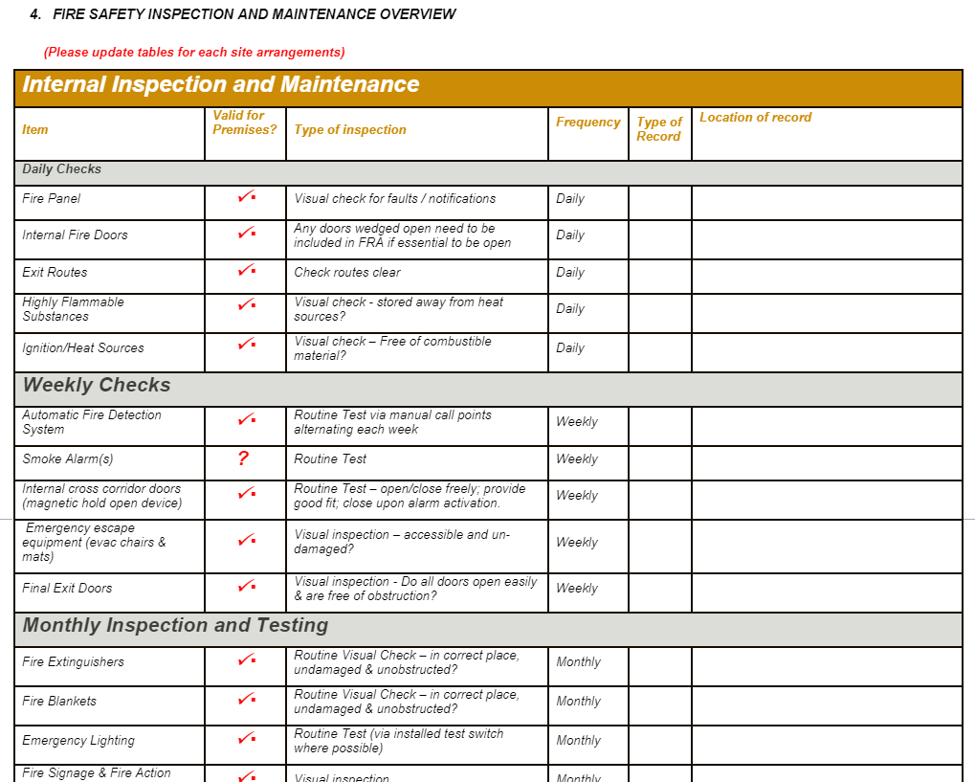

Recording Information and Record Keeping
Most records are kept and maintained by facility supervisors/PPP facility staff. Aberdeenshire staff training records are kept by the Head Teacher (Primary) Cluster Business Manager (Secondary) and individually by staff members on their ALDO accounts.

Audit and Review
The Aberdeenshire Council ECS Fire Audit Action Plan is completed annually using the ECS Fire Risk Assessment (FRA) which is a live document and subject to ongoing review and update.
Scottish Fire and Rescue Service currently audit on a three-yearly basis using the School’s FRA.
Health and Safety/Fire advice is available through the corporate Health and Safety Team on 01467 537515
Where there are significant changes to the premises (ie change of use/extension etc), please contact the H&S Team.

